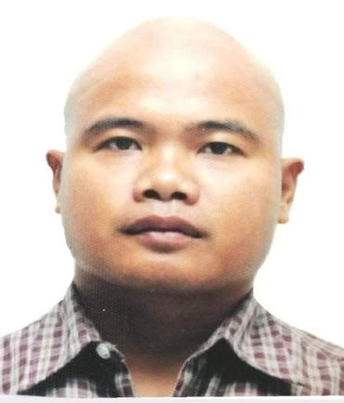
FLORENCE U. CASTILLO
Address:
Permanent: Malekkeg, Sta. Marcela, Apayao
Current Address: 203 Mc Kinley St. San Fernando, San Nicolas, Ilocos Norte
Contact Nos. 055 528 4134/09453613627 /
Email Address: florencecastillo1986@gmail.com

OBJECTIVES:

To be able to enhance to the best of my knowledge where I share my capabilities, ability, and to provide quality and efficient service to my employer, its clients and to the constituents extensively.

PERSONAL INFORMATION

Date of Birth: January 05, 1986
Age: 38
Civil Status: Married
Citizenship: Filipino
Sex: Male
Height: 5’2” ft.

EDUCATIONAL BACKGROUND

Tertiary/College Bachelor of Science in Nursing
Divine Word Colleg of Laoag
Laoag City, Ilocos Norte , Philippines
Inclusive Years: 2003-2004

Bachelor of Science in Criminology
Florencio L. Vargas College, Abulug Campus
Calog Sur Abulog, Cagayan
Inclusive Years: 2004-2008

Secondary Barocboc National High School
Bgy. San Carlos, Sta. Marcela, Apayao, Philippines
Inclusive Years: 1999-2003

Elementary Malekkeg Elementary School
Malekkeg, Sta. Marcela, Apayao
Inclusive Years: 1993-1999

TRAINING/S and CERTIFICATION/S

National Technical Certificate in Welding NC II
Shielded Metal Arc Welding (SMAW)
Certificate issued on December 12, 2008

National Technical Certificate in Welding NC II
Gas Metal Arc Welding (GMAW)
Certificate issued on January 29, 2009

SKILLS Good in interpersonal communication
Can perform basic computer skills
Welding
Ability to handle work under pressure
Learn and can adapt quickly to new environment

EMPLOYMENT HISTORY
- Mason
Hand Finisher
July 2009-June 2011
Raymond Saudi Arabia Ltd. Co
Kingdom of Saudi Arabia

- Quality Control
September 2011-January 2016
Raymond Saudi Arabia Ltd. Co
Kingdom of Saudi Arabia

- QA/QC
April 2018 – present
Raymond International Ltd. KSA Branch
Kingdom of Saudi Arabia

I hereby certify that the above information are correct and true to best of my knowledge.

FLORENCE U CASTILLO
Employee

