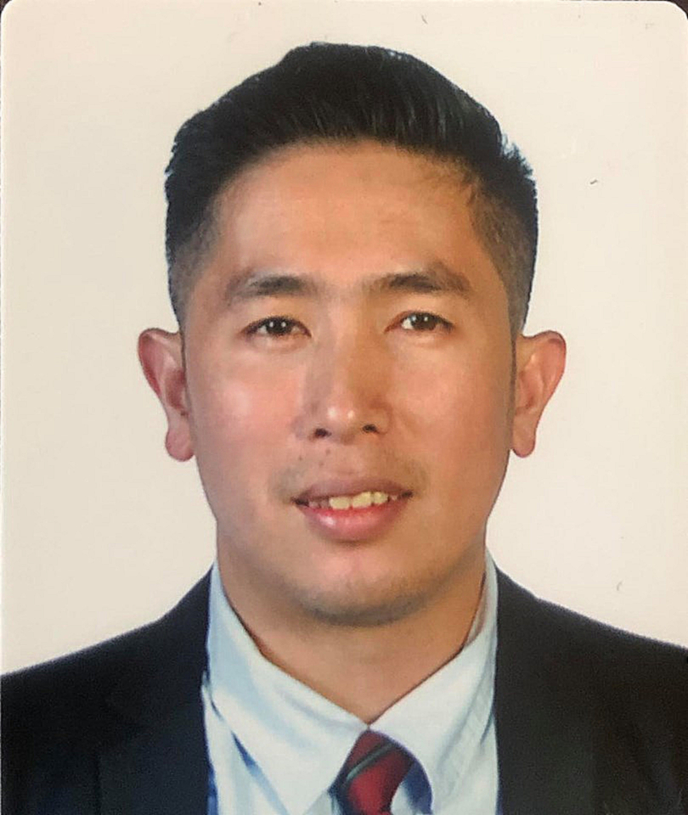
DENNIS MANALANSAN CARIÑO
#205 Sto Niño Street, San Antonio Valley 6, San Isidro,
Parañaque City,1715 Philippines
Phone #: 0966-644-8763
Email Address: denniscarino25@gmail.com

OVERVIEW:
Objective Statement : Enthusiastic and detail-oriented culinary professional with thorough understanding of health and safety regulations. Positive and reliable team player dedicated to efficiency and punctuality, with a proven ability to work well under pressure and to contribute my culinary expertise in preparing outstanding and commendable dishes to provide customers with excellent dining experience.

WORK EXPERIENCES:

Company Name : Brunch Bureau Proscenium
Address : 2nd Floor, Proscenium Bldg., Estrella, Makati City
Date : Dec 11 2023 to Present
Position : Line Cook

Key Contributions
- Set up and stocking stations with all necessary supplies
- Prepare food for service (e.g. chopping vegetables, butchering meat, or preparing sauces)
- Cook menu items in cooperation with the rest of the kitchen staff
- Answer, report and follow executive or sous chef’s instructions
- Clean up station and take care of leftover food
- Stock inventory appropriately
- Ensure that food comes out simultaneously, in high quality and in a timely fashion
- Comply with nutrition and sanitation regulations and safety standards
- Maintain a positive and professional approach with coworkers and customers

Company Name : Pad Thai in a Box
Address : Aguirre Avenue, BF Homes, Parañaque City Manila
Date : July 27 2023 to Dec 24 2023
Position : Cook

Key Contributions
- Ensuring high quality ingredients upon purchasing and storing.
- Clean food preparation areas before and after operation.
- Setting standardization in the dish and in kitchen operation.
- Mise en place all the required ingredients.
- Cooking dish with minimum time.
- Dispatch food according to company standards.
- Ensuring HACCP is properly implemented.
- Ensuring excellent quality of dish, portion of the dish before serving to customers.
- Maintaining high star rated online.
- Daily Inventory of stocks.

Company Name : Jewel Café and FoodHaus
Address : Eagle Crest, Bakakeng Baguio City
Date : July 2018 to March 2023
Position : Chef

Key Contributions

- Menu planning.
- Clean food preparation areas before and after operation.
- Setting standardization in the dish and in kitchen operation.
- Cooking dish with minimum time.
- Ensuring excellent quality of dish, portion of the dish before serving to customers.
- Maintaining high star rated online.

Company Name : Chalet hotel
Address : Upper Military Cutoff rd. Baguio City
Date : June 12, 2017 to January 13, 2018
Position : Cook

Key Contributions

- Menu planning for functions.
- Ensuring excellent quality of dish before serving to customers.
- Ensuring the quality portion size of each dish.
- Cooking dish with minimum time.

Company Name : Crown Legacy hotel
Address : Corner Montinola st. Kisad rd. Baguio City
Date : May 02, 2016–August 2, 2016
Position : Chef

Key Contributions

- Clean food preparation areas before and after operation.
- Presentation of food.
- Breakfast buffet menu planning and preparation.
- Weekend dinner buffet planning and preparation.
- Ensure high quality of food.
- Maintain sanitation, health and safety standards in work areas

Company Name : Café Will
Address : #11 MH Del Pilar St. Baguio City
Date : December 04, 2013 – April 21, 2015
Position : Cook

Key Contributions

- Clean food preparation areas before and after operation.
- Inspect food preparation and serving areas to ensure observance of safe,
sanitary food-handling practices
- Cook menu items in cooperation with rest of the kitchen staff
- Presentation of food
- Ensure high quality of food
- Maintain sanitation, health and safety standards in work areas

TRAININGS and CERTIFICATION

Certificate of Employment: Pad Thai in a Box December 2023
Certificate of Employment: Jewel Café and FoodHaus March 2023
National Certificate III in Ships Catering (Ships’ Cook) June 2022

Certificate of Completion
Survival Craft and Rescue Boats other than Fast Rescue Boats June 2022
Basic Training for Oil and Chemical Tanker Cargo Operations May 2022
Security Awareness Training and Seafarers with Designated Security Duties April 2022
Full Course Training in Ships Catering NCII(Ships Cook) April 2022
Basic Training April 2022

Certificate of Completion (OJT)
Essential Public Health: Covid-19 for Restaurant August 2021
ProChef1 August 2021
Hospitality Management August 2021
Food Service Manager August 2021
Food Handler August 2021
Fighting Food Waste in Hotels August 2021
Foundations for the Plant-Forward Kitchen August 2021
Flexible Industry Practicum for Culinary Management Track August 2021

Certificate of Completion (Other)
Certificate of Appreciation of TG Home Builders for Excellent Catering Service March 2020
2nd place in KLASIKA KORDILLERA KULINARYA Skills Competition September 2019
Cookery NCII January 2019
Food and Beverage NCII December 2018
Certificate of Employment in Chalet hotel June 2017
Certificate of Employment in Crown Legacy hotel May 2016
Certificate of Employment in Café will December 2014
Basic Cookery Town Gas Hong Kong November 2009

KEY SKILLS

Adaptability Attention to Detail Business Sense
Communication Health and Safety Creativity
Customer Service Passion Handle Pressure
Leadership Cooking Techniques Take Initiative
Critical Thinking Multitasking Planning
Team Work Flexibility Inventory Management

EDUCATIONAL BACKGROUND:
Tertiary: Batchelor of Science in Hospitality Management
Major in Culinary and Food Management
University of the Cordilleras
Baguio City , Philippines
SY 2018-2021
Hotel and restaurant Service
Diploma in Hospitality Management
BSBT College
Baguio City, Philippines
SY 2017-2018

Secondary: University of Baguio
SY 1996-1997
University of Cordilleras (former BCF)
SY 1997 - 2001

Primary: Saint Louis Pacdal
SY 1990 – 1992
University of Baguio
SY 1992 – 1996

PERSONAL DATA:

Date of Birth : February 25, 1983
Place of Birth : Dominican Malaya, Baguio City
Nationality : Filipino
Civil Status : Single
Height : 5’5”
Weight : 70kg.
Mother’s name : Yollanda Ferguson
Father’s name : Jovito Carino
Religion : INC

CHARACTER REFERENCES:

Mr.Darel Daria Mr. Richard Bustarde
Inventory Controller Owner
Crew ID :285192 Jewel café and foodhaus
Baguio City

Mr. Jacqueleene Karl Oamil
Camp Staff
Crew ID:482315


I certify that the above details are true to my knowledge and belief.

Dennis Cariño
Applicant

