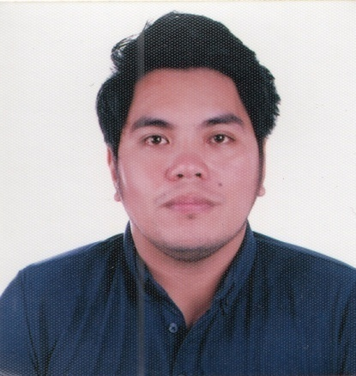
RESUME

A. PERSONAL BACKGROUND

NAME : Vincent Lee A. Auman
ADDRESS : San Vicente Beach Poblacion, Daanbantayan Cebu
SEX : Male
DATE OF BIRTH : May 27, 1991
PLACE OF BIRTH : Cebu City
AGE : 29 years old
FATHER'S NAME : Leonardo E. Auman
MOTHER'S NAME : Lina A. Auman
CIVIL STATUS : Single
HEIGHT : 5'5"
WEIGHT : 175 lbs.
NATIONALITY : Filipino
RELIGION : Roman Catholic
CONTACT # : 09238178938

B. EDUCATIONAL BACKGROUND

TERTIARY : Cebu Doctor's University
Bachelor of Science in Nursing
Mandaue City
2007-2011

SECONDARY : Saint Martin de Porres Academy
Daanbantayan, Cebu City
2003-2007

PRIMARY : Daanbantayan Learning Center
Daanbantayan, Cebu City
1997-2003

C. WORK EXPERIENCE

Chong Hua Hospital- Cebu: Pharmacy Assistant
October 2015 – February 28, 2021

Rose Pharmacy Inc.: Pharmacy Assistant
October 2012 - March 2015

D.CERTIFICATES

National Certificate III in PHARMACY SERVICES
Certificate #: AVA-91-187-07022-001
Valid until: July, 2024

E. TRAININGS and SEMINARS

- Basic Life Support (Hands-only CPR)
Chong Hua Hospital
September 26, 2019

- 3rd Chong Hua Hospital Pharmacy Post-Graduate Course
Theme: “Safe and Effective Medicines for All”
September 20-21, 2019

- Red Cross Training
Chong Hua Hospital
September 6-7, 2019

- 2nd Chong Hua Hospital Pharmacy Post-Graduate Course
Theme: “Remodelling the Pharmacy Services: Responsive to the Changing Time”
November 30, 2018 – December 01, 2018

- 1st Chong Hua Hospital Pharmacy Postgraduate Course
Theme: “Gearing Towards Patient Care”
Chong Hua Hospital Mandaue
December 02-03, 2017

- “Professionalization of Pharmacy Support Workforce through Outcomes-Based Learning
Diamond Suites, Escario Ext., Cebu
July 18, 2017

- 5S Orientation
Chong Hua Hospital
May 15, 2017

- Earthquake Module and Walkthrough Drill
Chong Hua Hospital
April 23, 2016

- GHP Quality Helathcare “Understanding Your Role”
Radisson Blu Hotel, Cebu City
April 13, 2016

- Infection Control Basic Course
Chong Hua Hospital
February 29, 2016

E. REFERENCES

- Mr. John Louise D. Raval
Chief Pharmacist
Chong Hua Hospital- Cebu
09177001581

- Ms. Generose L. Go
Assistant Chief Pharmacist
Clinical Pharmacist
Chong Hua Hospital- Cebu
09177799631

- Ms. Cloena C. Capapas
Assistant Chief Pharmacist
Out- Patient Department
Chong Hua Hospital- Cebu
09177222034

