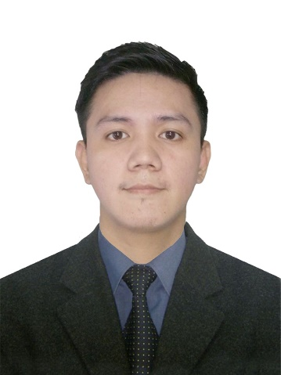
Arnel B. Dianito
0966-986-0124
Adianito016@gmail.com
113 Jude, Lacson St. Tondo, Manila, Philippines
_____________________________________________________
Objectives :
Applying for a challenging position that would enhance
my Knowledge, Skills, and Capabilities.
___________________________________________________________________
Personal Information:
Educational Attainment:

Tertiary
Housekeeping NC II
Sta. Isabel College of Manila
S. Y. 2016 –2016

Vocational
Computer Hardware Servicing NC II
Don Bosco TVET Center Tondo
S. Y. 2012 – 2014

Highschool
Dr. Juan G. Nolasco High School
S. Y. 2006 - 2011

Age : 28 Years Old
Date Of Birth : August 16, 1995
Place Of Birth : Metro Manila
Civil Status : Single
Citizenship : Filipino
Religion : Catholic
Height : 5’6”
Weight : 61kgs

___________________________________________________________________
Working Experience:
PC Options
21 Pecton Bldg. Gilmore Avenue Manila, Quezon City
Computer Technician
November 2013 – June 2014
Job Description:
- Responsible for maintaining the computer equipment and providing support to the customer.

PASCO Philippines Corporation
2301 Raffles Corporate Center Ortigas, Ortigas Center, Pasig City
Encoder
August 2015 – February 2016
Job Description:
- Creating and encoding a Map based project like google map.

Cinderella
625 Pedro Gil St. Ermita, Manila, 1000 Metro Manila
Fashion Consultant
June 2016 – September 2016
Job Description:
- Giving Assistance to the customer, and providing customer service.

Sta Isabel College
210 Taft Avenue, Manila
Housekeeping
November 2016 – February 2017
Job Description:
- Performing a variety of cleaning activities such as sweeping, mopping, dusting and polishing.
ILOVEMILKTEA
82 Victoneta Avenue, Potrero, Malabon
Barista
January 2018 – February 2019
Job Description:
- Serving and making a Bobba drinks, Frappes, and providing a customer service.

TEA TIME
601, 1008 Cayco St. Sampaloc, Manila
Head Barista
March 2021 – December 2021
Job Description:
- Serving and making a Bobba drinks, Frappes, doing online orders, and providing customer service

PC EXPRESS
159 M. Paterno St. Barangay Pasadena, San Juan
Inventory Personnel
Present Work
Job Description:
- responsible for checking shipments going in and out of the company and ensuring that all orders are delivered correctly. And preventing the discrepancy of the items.

Character References:
Mr. Eugene Adrid
Trainer
09351389817

Mr. Michael Manlapaz Mr. Dino Razalan
Warehouse Manager Warehouse Supervisor
09088114686 097060154444

