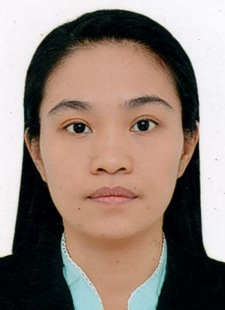
DOLORES ALILAO-OLIVA
BLOCK 1, LOT 8 PHASE 1-F, GOLDEN WOOD STREET
GREENWOODS EXECUTIVE VILLAGE, SAN ANDRES
CAINTA RIZAL
MOBILE NO. : 0947-3687-796
Email: dallyallallao@yahoo.com

PROFESSIONAL OBJECTIVE
To share my knowledge and skills that I have acquired in the school, training and seminar attended.

EDUCATIONAL BACKGROUND

Tertiary:
Bachelor of Science in Nursing
University of Baguio
Baguio City Philippines
S. Y. 2009-2013

Secondary:
Araullo High School
United Nation Taft Avenue
Ermita Manila
S. Y. 2001-2005

Primary:
Tawang Elementary School
Beleng Belis, Kapangan Benguet
S.Y. 1995-2001
TRAINING ATTENDED
- National Certificate 11 in Caregiving
Technical Education and Skills Development Authority (TESDA)
February 10-13, 2014

SEMINARS ATTENDED
- Emergency Trauma Care; Saving Lives
Philippine Nurses Association Inc.
November 23, 2016
- Emergency Cardiac Care Guidelines
Philippine Nurses Association Inc.
November 25, 2016
- Evidence-Based Nursing; Competences, Challenges and Directions
Philippine Nurses Association Inc.
February 08, 2020
- COPD Management; A Team Approach
Philippine Nurses Association Inc.
February 08, 2020

SKILLS
- Basic computer knowledge
- Good in active listening
- Therapeutic massage

WORKING EXPERIENCE

- PRIVATE DUTY NURSE/CAREGIVER
Employer- Joseph De Temmerman-Belgian National
Cityland VIII No. 98 Senator Gil Puyat Avenue
Makati City
April 15, 2014-August-31, 2019

PERSONAL INFORMATION

Date of Birth: March 5, 1985
Place of Birth: Kapangan Benguet
Gender: Female
Status: Married
Weight: 54kg
Height: 5’1”

REFERENCE

Jean Rose Rosales RN
Tricity Medical Center
269 C.Raymundo Ave. Maybunga Pasig City

I hereby certify that all information given in this data are complete and correct to the best of my knowledge, beliefs and ability.

Sincerely,

DOLORES ALILAO-OLIVA

