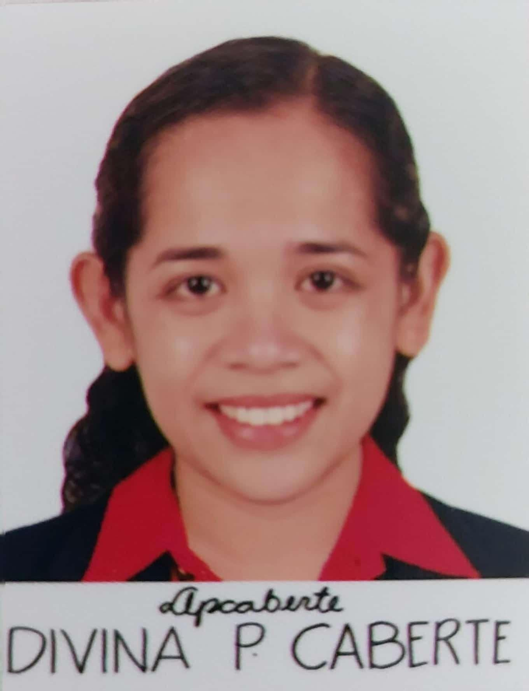
DIVINA P. CABERTE, RN
Purok II Poblacion, Calinginan Norte, Sevilla, Bohol 6347
Contact No.: 09275684038
E-mail: cabertedivina5@gmail.com
Facebook: Dabey Bear

OBJECTIVE

A nurse practitioner with several years of experience in providing quality nursing care to a wide range of hospital and community-based patients. I want to enhance my knowledge and skills by becoming part of your institution.

PERSONAL DATA

Birthday: March 12, 1990

Birthplace: Sevilla, Bohol

Age: 33

Civil Status: Single

No. of children: 2

Religion: Roman Catholic

WORK EXPERIENCE

May 2, 2023- Dec. 31,2023 NDP (NURSE DEPLOYMENT
PROJECT)
Department of Health (DOH)

Duties and Responsibilities:
- Providing nursing services and Healthcare education at homes and community clinics.
- Developing treatment and intervention plans based on Healthcare assessments.
- Instructing families on patient care and promoting healthy lifestyles.
- Coordinating treatment , convalescence and rehabilitation plans with other Healthcare providers.
- Providing maternity and childcare guidance as well as facilitating interventions when required.
- Conducting immunization programs as well as promoting disease prevention and control measures.
- Participating in health education initiatives and keeping abreast of advancements in that field of public health

January 25,2023 – April 30, 2023 NURSE
LGU SEVILLA

Duties and Responsibilities:
- Collated medical data for patient records, maintaining strict confidentiality.
- Maintained continued personal development through regular training, maximizing nursing capabilities and competence.
- Actively prompted best nursing practices, leading by example in providing accurate, prompt patient provisions.
- Performed in-depth prevention assessments, maintaining patient health and safety.
- Prepared patients for medical procedures, providing reassurance and practical advice to ease concerns
- Communicated with healthcare team to evaluate and execute proper patient care plans.
- Communicated with patients and families to inform current condition and treatment options.
- Measured blood pressure, pulse and temperature to assess and record vital signs.

Sept. 3, 2018 – Dec. 31, 2022. NDP (NURSE DEPLOYMENT
PROJECT)
Department of
Health (DOH)
Duties and Responsibilities:
- Providing nursing services and Healthcare education at homes and community clinics.
- Developing treatment and intervention plans based on Healthcare assessments.
- Instructing families on patient care and promoting healthy lifestyles.
- Coordinating treatment , convalescence and rehabilitation plans with other Healthcare providers.
- Providing maternity and childcare guidance as well as facilitating interventions when required.
- Conducting immunization programs as well as promoting disease prevention and control measures.
- Participating in health education initiatives and keeping abreast of advancements in that field of public health.

January 4,2016- August 30,2018 STAFF NURSE
NICU & OB WARD
DON EMILIO DEL VALLE
MEMORIAL HOSPITAL
Duties and Responsibilities
- Prepared the nursery room, machines and supplies for admission
- Kept the incubator warm and ready for admission
- Received the baby from Delivery Room or Operating Room depending upon the case
- Routine Newborn care and assessed physical status and condition of the newborn
- Monitored and recorded of vital signs of the baby to include the head, chest and abdominal circumference as well as weight and length
- Administered oxygen therapy as per order of the pediatrician/neonatologist
- Performed medical procedures; for example, inserting intravenous lines, performing tests, and administering medications
- Assisted the Neonatologist and Consultant in medical procedures and treatments. Using and adjusting specialized medical equipment
- Formulated nursing plans and evaluating the effectiveness of treatments
- Offered support to the parents with premature and sick newborns
- Educating patients on family planning, fertility and health-related decision during pregnancy
- Advising patients on risks and options when facing abnormal pregnancies or pregnancy complications
- Prepping the patient and exam room for labor and delivery
- Assisting obstetricians and midwives during delivery
- Monitoring women’s health after delivery
- Providing education to new parents on newborn care, including breastfeeding, changing, swaddling, feeding, bathing and nutrition.

CASES HANDLED:
- Extreme Pre-term babies
- Neonatal Jaundice
- Respiratory Distress Syndrome
- Neonatal Sepsis
- Neonatal Anemia
- Neonatal Apnea
- Bronchopulmonary Dysplasia
- Intraventricular Hemorrhage
- Transient Tachypnea in Newborn
- Patent Ductus Arteriosus
- Normal Spontaneous Vaginal Delivery
- Forcep/ Vacuum Delivery
- Vaginal Birth after Cesarean
- Labor Complications such as PROM’s Pre-eclampsia, Failed Progress of labor, Antepartum hemorrhage and CPD
- Delivery Complications such as Dystocia, Cord Prolapse, Retained Placenta, Ruptured Uterus and Infection

EQUIPMENT USED:
- Incubator
- Mechanical Ventilator
- Resuscitator
- Infusion Pumps
- Phototherapy Machine
- Vital Signs Monitor
- Umbilical Catheter
- Suction Machine
January 2015- January 2016 STAFF NURSE
(ER WARD & GENERAL
WARD)
Borja Family Hospital
Corporation
Duties and Responsibilities
- Maintained accurate, complete health care records and reports.
- Assessed and gave immediate nursing care to patients being brought to ER specially those involved in Motor Vehicular Accidents
- Assessed the needs of the patients in the ward and made nursing care plan and intervention for all patients
- Gave direct patient care (bed making, changing of bed sheets, mouth care, back care, bed bathing, hair wash, changing of position)
- Fulfilled all basic needs (hygienic need, nutritional need, etc.) of the patients.
- Provided comfort to the patient and maintaining safety
- Received endorsements of previous shift, regarding patients (bed to bed), instrument supplies, drugs and handed over the same to the next shift
- Prepared and transported patients for referrals to higher facilities.

CASES HANDLED:
- Motor Vehicular Accident related Injuries
- Gunshot Wounds
- Stabbed Wounds
- Acute Respiratory Infection
- Diarrhea
- Tuberculosis
- Cardiac Arrest
- Influenza

EQUIPMENT USED:
- BP Apparatus
- Suction Machine
- Suturing Sets
- Sterilizers

EDUCATIONAL BACKGROUND

- June 2007 – April 2014 Holy Name University
Bachelor of Science in Nursing

- June 2002- April 2006 Cambagui- Calinginan Norte
National High School

- June 1996- March 2002 Cambagui Elementary. School

TRAINING/ SEMINAR
August 15-18, 2023 Standard First Aid & Mass Casualty Management Training

March 28-29, 2022 Basic Life Support Training

August 01, 2018 Lecture on Perioperative Nursing

CHARACTER REFERENCES

Name: Criselyn O. Cañeda, RN
Position: NICU/ SEPTIC-NICU SUPERVISOR
Company: Don Emilio Del Valle Memorial Hospital

Name: Clarice Nova C. Pacatang, RN
Position: DMO IV
Company: Department of Health
Contact Details: 09992269385

Name: Angelie M. Canono, RN
Position: Public Health Nurse
Company: RHU Sevilla-Bohol
Contact Details: 09636904757

