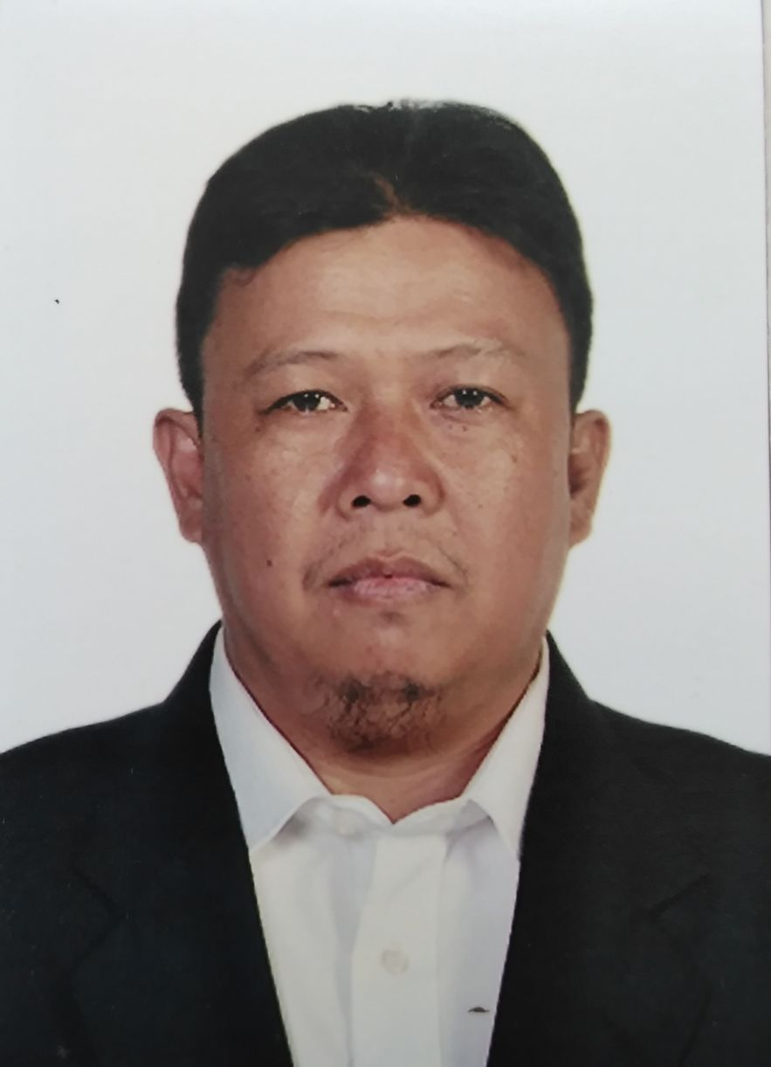
Julius D. Duran
Purok 3 Dacudao Calinan, Davao City
Mobile no. 09195027881, 09067671836
E-mail: arcyld@gmail.com
Facebook: https://m.facebook.com/juluse?ref=bookmarks

POSITION APPLIED: TRAILER/TRUCK DRIVER

OBJECTIVE: Energetic, confident individual seeking work as trailer/truck driver with my considerable trucking skills along with a great ability to drive in a safe manner in order to provide excellence in delivery services.

PERSONAL DATA:

Date of Birth: July 13, 1978
Place of Birth: Davao City, Philippines
Civil status: Married
Age: 45
Height: 5’4”
Weight: 70 kg.
Religion: Roman Catholic
Spouse name: Arcyl Dapusala Duran
No. Of children: 3
Name of Parents: Jaime Gonzaga Duran
Ma. Flordeliza Doromal Duran

EDUCATION:

1996 TO 2000 – Jhon Paul II College of Davao Information Technology (3rd Yr. Undergraduate)
1992 TO 1995 – Calinan National High School (Dacudao annex) Secondary
1986 TO 1992 – Lt. Cipriano Villafuerte Sr. Elementary School Primary

WORK HISTORY:

COMPANY: ALMARAI COMPANY (Transport Division)
POSITION: LONG HAUL TRAILER DRIVER
DATE: October 21, 2016 – October 21, 2020
LOCATION: Alkharj, Riyadh Saudi Arabia
HEAVY EQUIPMENTS HANDLED: VOLVO FH440, MAN TGS 19.440, Flat bed,
JOB DESCRIPTION: To haul and transport Cows manure, cows food like Rhodes grass or hay grass from Agricultural farm etc. to Dairy farm, mostly we do haul corn, soya bean, sugar beat pulp from port transported by a cargo ship coming from other country and we will be transported to the dairy farm.

WORK HISTORY:

COMPANY: WARED TRANSPORT LOGISTICS
POSITION: TRAILER DRIVER
DATE: June 4, 2014 – June 10, 2016
LOCATION: Jeddah, Kingdom of Saudi Arabia
PROJECT: King Abdullah Port (national container terminal)
HEAVY EQUIPMENTS HANDLED: Volvo FH 440, Renault 440, (flatbed, side curtain trailer)
JOB DESCRIPTION: To deliver and transport full of container livestock products, or resources, usually whole Kingdom of Saudi Arabia (long haul).

WORK HISTORY:

COMPANY: MOHAMMED ALI AL SWAILEM CO. (MASCO)
POSITION: ACCOUNTS COST CLEARK
DATE: December 19, 2009 – November 10, 2012
LOCATION: Rabigh, Jeddah Kingdom of Saudi Arabia
PROJECT: Al Haramain high speed rail
JOB DESCRIPTION: To do the inventory expenses of each heavy equipment unit in how much its daily cost like, oil, filters, diesel consumed everyday. And to prepare the schedule of each units preventive maintenance schedule.

WORK HISTORY:

COMPANY: DAVAO VENTURES CORPORATION (DAVCO)
POSITION: TRUCK DRIVER
DATE: March 2009 – Dec 2009
LOCATION: Wangan, Calinan Davao City, Philippines
PROJECT: Pineapple Plantation
EQUIPMENTS HANDLED: Mitsubishi Canter (elf truck)
JOB DESCRIPTION: To load pineapple fruits from area of harvested to packing house.

WORK HISTORY:

COMPANY: HAPPY JACK ORGANIC CORPORATION (HJOC)
POSITION: LEADMAN/TOOL KEEPER (Fruit care operation)
DATE: September 2007 – February 2009
LOCATION: Sinuda, Kitaotao Bukidnon Philippines
PROJECT: Banana Plantation
JOB DESCRIPTION: To supervised and dispatch laborers to their respective area of assignment.

WORK HISTORY:

COMPANY: OFFICE OF THE CONGRESSMAN RUY ELIAS LOPEZ (3rd district)
POSITION: Office staff, Data Entry
DATE: 2001 – 2007
LOCATION: Matina, Davao City Philippines
JOB DESCRIPTION: To received and released the request of the barangay officials of the district.

WORK HISTORY:

COMPANY: LOCAL GOVERNMENT UNIT
POSITION: SANGGUNIANG KABATAAN (SK) CHAIRMAN
DATE: 1996 – 2001
LOCATION: Baranggay Dominga, Calinan Davao city

SKILLS:

Good interpersonal skills to maintain and establish co-worker and costumer rapport.
Knowledge of driving techniques and procedures.
Long haul, mid haul, service vehicle.
Able to communicate effectively among costumers.
Understanding of driving laws.
Able to follow rules and regulation of driving.
Capable to complete most difficult trips.
Able to drive accurately.
Computer literate, Microsoft word, excel, power point.

