Peter Jun S. Lawagan
Baguio City, Philippines
Cellphone No.: +639604570722

POSITION DESIRED
GMAW/GTAW/SMAW WELDER

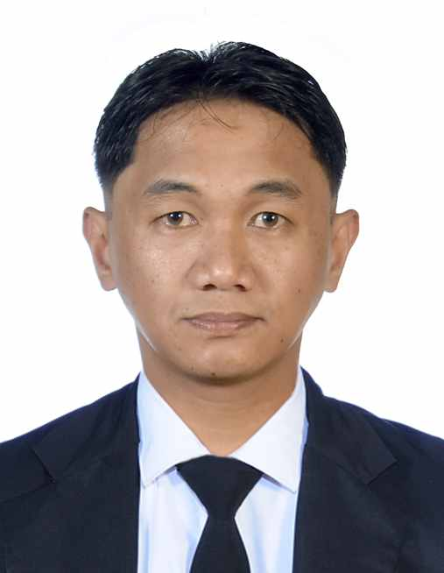
WORK EXPERIENCE

1. Position: GTAW/SMAW WELDER
Duration: August 23, 2018 – September 31, 2023
Company: Hokuchiku Dengyo Co. Ltd.
Country: Japan

Scope of Work:
- Weld but joint Carbon Steel pipes, P11 and P21 alloy steel pipes using GTAW process.
- Weld socket joints Carbon Steel Stainless Steel and Alloy steel pipes.
- Perform pre heat and post weld heat treatment.
- Fabricate pipe supports using Smaw process.

2. Position: GTAW/SMAW WELDER
Duration: October 2016 – July 2017
Company: Sungchang Engineering and Construction
Project: TACE-Turkmenistan Ethane Cracker and Polyethylene Plant
Country: Turkmenistan

Scope of Work:
- Weld Carbon steel pipes Using GTAW/GMAW combination.
- Group preparation and Fit-up of pipes.

3. Position: GTAW/SMAW WELDER
Duration: February 2015 – April 2016
Company: IWI Limited Engineering and Construction
Project: Jeddah South Thermal Power Plant
Country: Saudi Arabia

Scope of Work:
- Fit up and Weld heavy wall pipes.
- Preheating of weld joints subject to weld.
- Weld stainless pipes using GTAW process.
- Repair weld joints that failed in Non-destructive test.

4. Position: GTAW/SMAW WELDER
Duration: June 2013 – June 2014
Company: Sungchang Engineering and Construction
Project: Maaden Aluminum Refinery Project
Country: Saudi Arabia

Scope of Work:
- Weld carbon steel pipes using GTAW/SMAW process.
- Fabricate and weld structural and install structural materials such as
H beam, channels.
- Install gratings and handrails.

5. Position: GTAW/SMAW WELDER
Duration: February 2012 – December 2012
Company: Sungchang Engineering and Construction
Project: Ruwais Refinery Expansion Project
Country: Abu Dhabi United Arab Emirates

Scope of work:
- Weld carbon steel pipes Using GTAW/SMAW process.
- Weld pipe support such as saddle support and shoe support.

EDUCATIONAL BACKGROUD

College: University of the Cordilleras
Field of Study: Bachelor of Science in Criminology
Year Graduated: 2nd Year Undergraduate (2004-2006)

Vocational: Baguio School of Business and Technology
Field of Study: Automotive Mechanic
Year Graduated: March 2007

Secondary: Baguio City National High School
Year Graduated: March 2004

Primary School: San Vicente Elementary
Year Graduated: March 200

TRAININGS

Gas Metal Arc Welding NC II
August 28, 2023 – October 16, 2023
Technical Education and Skills Development Authority(TESDA)

Gas Tungsten Arc welding NC II
July 2011
Kimlar Technical and General Services

Shielded Metal Arc Welding NC II
July 17, 2007 – August 31, 2007
Technical Education and Skills Development Authority(TESDA)

PERSONAL INFORMATION

Age: 36
Date of Birth: October 9, 1987
Place of Birth: Baguio City, Philippines
Nationality: Filipino
Religion: Roman Catholic
Marital Status: Single
Gender: Male
Height: 165 cm’s
Weight: 66kgs

REFERENCES

Kozo Kira
Representative Director
HOKUCHIKU DENGYO Co. Ltd.
hokutiku@hokutiku.com
+81-93-982-2559

Supporting documents will be submitted upon the request of the employer.

I certify that the above information is true and correct to the best of my knowledge.

Peter Jun S. Lawagan
Applicant

