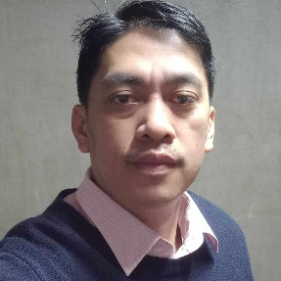

pitching in to help achieve team goals.

team members history of working well with other team members and
and packaging shipments. Excellent history of working well with other
hours in challenging environments, moving supplies, organizing products
Hardworking Factory Worker offering 9 years and 5 months supporting

manufacturing needs. Successful working long hours in challenging

PRODUCTION CREW
- Machine Operator
09624100814
E-mail
sinambanhowell415@gmail.com
com
Nationality
Filipino
09566590295

fragile products
- Keep the worksite clean to avoid hazards from chemicals and
- Meet the deadlines of individual production tasks during shift.
- Operate production equipment.
- Follow the company safety and quality guidelines
Ace Hardware Incorporated, SM Mexico, Pampanga, Philippines
Sales Assistant
Education

for merchandise at other sites.
and via telephone
nameplates for sales team.
- Facilitated ordering and processing of business cards and
- Assisted customers with prompt and polite support in-person
- Helped customers locate products and checked store system
Holy Angel University – Angeles City, Philippines
Bachelor of Business Administration Marketing
2003-04
1998-06-
2003-10 -
2012-12
eliminate problems.
- Monitored machines during operation to detect sounds of
malfunction or excessive vibration and adjusted machines to
- Operated machining equipment safely with team of operators.
components.
- Maintained equipment performace by lubricating and cleaning

PLASTIC INJECTION
South Korea
Hyeon Ji Gyu, Chungcheongbuk-do, Jincheon Gun 311 Munsaro,
2020-09
2013-01-
POLYTECH (Factory Worker)
before serving to customers.

- Verified prepared food met standards for quality and quantity
operating machinery, using sharp tools and handling chemicals.
- Observed company safety procedures and standards when
- Maintained clean work areas for optimal food quality.

equipment, conveyors, and staging areas.
- Supported current production needs by moving items between
FOOD PROCESSING
South Korea
Jang-Hyun-Seong, Samseong- myeon, Chungcheongbuk-do,
2022-05
2020-10 -
IMOKWON (Factory Worker)

GSMP Bldg., Dolores, City of San Fernando, Pampanga
JMP TWIN EAGLE MANPOWER & ALLIED SERVICES INC.
present
up to
2023-10

Work History
09162006378
Phone
#228 Barrio Street Anao,

2021, Mexico, Pampanga
Address

Languages
Skills
Contact
English
Korean
Equipment monitoring
Assembly and production
Stocking and replenishing
Equipment operation
Machine Operator
Forklift Operator
Sinamban

Business Management
Howell

