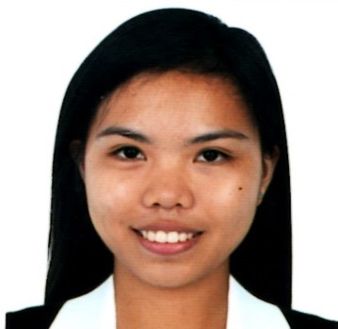
Phone
0976-364-0495
Email
alexajoyceborgonia@gmail.com
Address
micara estate sahud ulan, tanza, cavite
Alexa joyce d. borgonia

Character reference
Cherry Lyn Arevalo Teacher 0995-884-6615

I HEREBY CERTIFIED THAT THE ABOVE INFORMATIONS ARE TRUE AND CORRECT TO THE BEST OF MY KNOWLEDGE AND BELIEF.

ALEXA JOYCE D. BORGONIA
SEMINAR/TRAINING SKILLS
- Certificate of Completion in Employability Skill Training Luis Y. Ferrer Jr. Senior High School October 23-25, 2017

- Certificate of Completion in On-the-Job Training in Department of Public Workers and highways under the program from Luis Y. Ferrer Jr. Senior High school 2018

- Certificate of Completion in On-the-Job Training in Municipality of Tanza under the program from Cavite State University – CCAT Campus 2019

- Certificate in National Service Training Program-CWTS under the program from Cavite State University-CCAT Campus 2018-2019

- Certificate of Completion in Autodesk Authorized Academic Partner (Fusion 360) Cavite State University-CCAT Campus 2018-2019
Personal skills & Assets
- AutoCAD (2D modeling, Architectural and Structural)
- Manual Drafting
- Hardworking and responsible
- Willing to learn new things
- Flexiible
- Teamwork and collaboration

Personal data
Date of birth: august 29,1999
Place of birth: tejero city of gen. Trias, cavite
Age: 23
Civil status: single
Religion: catholic
Sex: female
Language known: english & tagalog
Height: 5’4’’
Weight: 50kg

HONORS/ AWARDS RECEIVED

NC II Holder in mechanical drafting (2018)

EDUCATION
Cavite State University- CCAT Campus
Bachelor of Science in Industrial Tech. Major in Drafting Tech. 2018 - Present

Luis Y. Ferrer Jr. Senior Highschool
TVL- Drafting Technology
2016 - 2018
Square Village, General Trias, Cavite

Governor Ferrer Memorial National High School (Main)
2012 - 2016
Pinagtipunan, General Trias, Cavite

General Artemio Recarte Memorial School
2006 - 2012
Malabon, General Trias, Cavite

Objective
To acquire valuable knowledge and skills to complement those that I have learned from school in an actual job environment.

