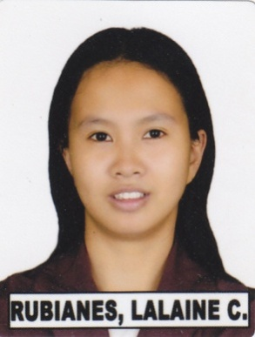

Lalaine C. Rubianes, RN
#05 Del Rosario Umingan Pangasinan, Philippines
Email Address: lalainerubianes@yahoo.com
Mobile: 09054257277

Career Objective
- To promote and implement the standard of nursing practice as established by the profession and to purse a nurse position which will require me to expand my practical experience while providing eminent healthcare efficiently and effectively in globally competitive world of expertise.

Work experiences

- Marcelo Hospital Staff Nurse (April 2005 – April 2010)
Pediatric Ward
Baliuag, Bulacan Philippines

- Riyadh Care Hospital Staff Nurse (May 2010 – June 2012)
Ob-Gynecology / Maternity ward
Riyadh Saudi Arabia

- Dr. Sulaiman Al-Habib Staff Nurse (January 14, 2013 – January 13, 2017)
Medical Group Ob-Gynecology / Maternity
Riyadh Saudi Arabia

- King Fahad Specialist Hospital Staff Nurse (January 2018- January 2023)
Accident and Emergency Room
Buraidah Qassim KSA

Certification

- Registered Nurse (PRC) June 2005 – December 2022

- Saudi Commission for March2009-2019
Health Specialist

- Basic Life Support (BLS) October 2015-2017
Job Descriptions
- Demonstrate clinical competency by consistently providing and preventing and evaluating the effectiveness of care given by self and other care team members.
- Maintain confidentially of patient and personnel care.
- Establish priorities based on patient availability of resources of time, personnel equipment and supplies.
- Serves as role model preceptor and resources person in providing and supervising clinical practice.
- Demonstrate professional accountability by participating and continuing educational programs.
- Document all nursing care professionally and accurately.
- Perform other applicable task and duties.
- Demonstrates ethical and appropriate behavior for clinical environment to include but not limited to patient dignity and privacy.
- Assisting physicians and all other healthcare professionals when caring for the patient and always giving a complete and thorough report on patient status at the end of the shift.

Education Background

- Elementary Umingan Central Elementary School
Umingan Pangasinan
1992-1997
- Secondary Immaculate Conception Catholic School
Umingan Pangasinan
1997-2001
- Tertiary Pines City College
Baguio City, Benguet
Bachelor of Science in Nursing
2001-2005
Character References

Ms. Rose Queja Head Nurse-Maternity Hospital
+966 56 6009 793 Dr. Sulaiman Al-Habib Medical Group
quejarose@yahoo.com

Dr. Mohamad Osman Ob-Gynecology Consultant
+996 64 6604 434 Dr. Sulaiman Al-Habib Medical Group

Ms. Ranyeh Nasser Nurse Manager-Maternity Hospital
+966 11 4622 224 ext 3321 Dr. Sulaiman Al-Habib Medical Group

Personal Information

Height : 5 feet
Weight : 65 KG
Gender : Female
Status : Married
Date of birth : December 26, 1984
Age : 37 years of old
Place of birth : Umingan Pangasinan
Religion : Roman Catholic
Citizenship : Filipino

I hereby certify that the above information’s are all true.

Lalaine C. Rubianes
Registered Nurse

