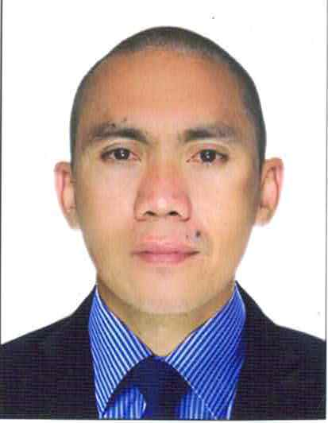
WILLY MARTINEZ PUJALTE
willypujalte1981@gmail.com
+63955 6527485
whatsapp / messenger
San Juan City, Metro Manila

OBJECTIVE:

Secure a responsible career opportunity to utilize my training and skills while making a significant contribution to the success of the company

WORK EXPERIENCE
Company Name : Pedro Cruz Elementary School
Address : San Juan City, Metro Manila
Position : Utility Maintenance
Date of Employment : June 07, 2023 – to present

Job Description :
- Responsible for cleaning and maintaining school premises and facilities
- Repair broken windows and broken tiles
- Maintain cleaning of comfort rooms
- Installation o ceiling fan, wall fan and other equipments
- Repair of plumbing services and basic electrical services to comply with state health and safety regulation

Company Name : BF Metal Corporation
Address : Ortigas Extension, Cainta, Rizal
Position : SMAW Welder
Date of Employment : February – April 2023
Job Description :
- Operate and maintain the machines that make welding and repair metal structures using 7018 welding rod
- Fabrication metal structures by using welding procedure by using cutting, shaping and various measuring tools.
- Repairing damaged structures and parts like structural ibeams or plate
- Measuring and cutting metal components to required specifications
- Inspecting completed welds for defects and ensuring structural integrity
- Follow standard specification of welding procedure
.
Company Name : Ursolino Welding Shop
Position : Welder / Fabricator
Date of Employment : June 5, 2021 – December 20, 2021

Job Description :
- Pipe bonding and fabricate of metal components
- Assembling, cutting, grinding, welding
- Welds and assemble metal pieces and products using handheld welding equipments
- Set up parts for welding using hand tools, clamps, jigs and fixtures

Company Name : Emeritus Security System, Inc.
Position : Security Guard
Date of Employment : August 19, 2017 – May 02, 2021

Job Description :

- Secures premises and personnel by patrolling property, monitoring surveillance equipment and access points
- Investigates security breaches incidents and other alarming behavior
- Recording / monitoring all incoming visitor or guests with log-in and log-out using my logbook
- To protect lives and property of the clients
- Maintaining peace and order within the vicinity in my place of duty

Company Name : International Metal and Construction Company (IMAC)
Position : Structural Fabricator
Date of Employment : May 05, 2015 – May 04, 2016

Job Description :
- Monitoring the fitting, burning and welding process to avoid overheating parts
- Heating formed and dressing metal parts with hand tools, torch
- Following instructions of tasks from foreman or supervisor
- Following the welding procedures
- Knowing the measurement and thickness of the metal before fabricating

Company Name : Saudi Oger Ltd.
Position : SMAW Welder
Date of Employment : July 13, 2013 – August 10, 2014

Job Description :
- Fabricating and assembling of pipe support or pipe rack
- Ensuring all equipment set up, are used safely and all safety devices are properly used/wore
- Following health protocols and safety measures
- Maintaining cleanliness within the working area all joint of metal using different positions (flat, horizontal, vertical, and overhead position)
- Cutting using oxy-acytelene gas, welding and grinding

Company Name : Hanjin Heavy Industries and Construction (HHIC)
Subic, Zambales
Position : FCAW Welder
Date of Employment : October 15, 2007 – November 15, 2008

Job Description :

- As a FCAW welder I am responsible for being proficient in the FCAW process to weld various components in flat, vertical, or overhead position
- Welding and assemble parts of the ship
- Knowledge in reading planned projects and designed
- Knowledge in gas cutting (oxy-acetylene)
- Knowledge in manual and semi-gas automatic gas cutting

EDUCATION BACKGROUND

Tertiary Education : Manuel S. Enverga University Foundation
Course : Automotive Technology
Year : First semester undergraduate (2002 – 2003)
Place : Lucena City, Quezon Province

Secondary Education : Alabat Island National High SchoYear
Graduated : 1998
Place : Alabat, Quezon Province

TRAININGS / AWARDS / CERTIFICATE / SEMINARS

YWA Trade test and Training Center Inc.
Ermita, Maila
Gas Metal and Welding (GMAW NCII)
September 03, 2014 – Novenber 29, 2014

PEDRIGAL Welding Reseach and Training Center Inc.
Pasig City
Gas Tungsten Inert Gas (GTAW NCII)

KEA INDUSTRIAL CORPORATION
Cavite, Philippines
Welded Parts Verification
(Macro Test Procedure)
April 01, 2011

HANJIN HEAVY INDUSTRIES CORPORATION (HHIC)
Subic, Zambales

KC TECH TRAINING CENTER
August 25 to October 12, 2007

SKILLS:
- Knowledge how to welding of SMAW Welding
- Knowledge how to use a MIG / MAG Welding with flat, horizontal, vertical and overhead position
- Knowledge of FCAW welding, gouging, grinding
- Knowledge of using oxy-acytelene gas
- Fabricator for structural
- Knowledge how to use drill press, bench grinder, bench vise, and other tools

REFERENCE :
Florence Ares
Principal
Pedro Cruz Elementary School
San Juan City, Metro Manila, Philippines

WILLY MARTINEZ PUJALTE

