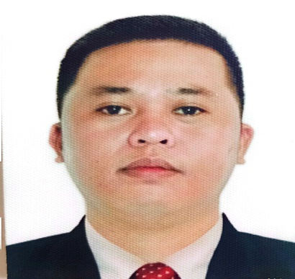
KEVIN M. TORCINO
San Nicolas 1 Bacoor City, Cavite
0909 271 4682 kevintorcino95@gmail.com
__________________________________________________________________________________
PERSONAL INFORMATION:
Date of Birth: July 28, 1992
Place of Birth: P2, Anislagan, Placer, Surigao Del Norte
Age: 31
Civil Status: Single
Language/Dialect Spoke: English/Tagalog/Cebuano
Personal Traits: Hard Working, Responsible, Honest, Trustworthy and Eager to Learn
Religion: Roman Catholic
Nationality: Filipino
Height: 5’8
Weight: 72 kls
EDUCATIONAL ATTAINMENT
Tertiary Education
School: Mindanao State University (Main Campus)
Address: Marawi City
Course: Bachelor of Science in Agricultural Engineering
School Year: 2011 – 2014
Secondary Education
School: Mindanao Emiliano Florendo Academy
Address: Bad-as Placer, Surigao, Del Norte
School Year: 2005 – 2009
Primary Education
School: Lower Libas Elementary School
Address: Lower Libas, Tagana-an, Surigao Del Norte
School Year: 2000 – 2005

WORK EXPERIENCE:

JSA INCORPORATION
Court 25 Greenhill’s, Annapolis San Juan City
March 08,2023 – June 03, 2023

Equipment Control Officer
- Supervised all sites
- Familiarized all the sites
- Inspect all the equipment in all sites
- Making incident and accident report
- Making reports and queries in all sites
- Purchase Request in all equipment’s
- Making daily task in all sites
- Making Cash Advance
- Coordinate to all sites and concerns
- Coordinate to all supplier’s equipment
- Update the scorecards and dashboard
- Checking inventory all equipment’s to all sites
- Determined the repair maintenance of the equipment's
- Evaluate the main causes of a repair equipment’s
- Up to date all the supplier’s daily
- Review the needs of all equipment materials in all sites
- Recommend for approval in the top management
- Update all the insurance of vehicles and equipment’s
- Do extra mile in a work

RICOA COMFOODS
130 Edsa corner 1550, Mandaluyong City

Production Worker
- Packing products for shipment
- Following health and safety standards
- Assembling parts and product’s
- Following production guidelines and specifications
- Working on production line and meeting production target’s
- Reporting the issues to the supervisors on duty
- Performing other tasks as assigned
- Maintaining a clean workstation and production floor
- Operating and maintaining machinery and production line equipment

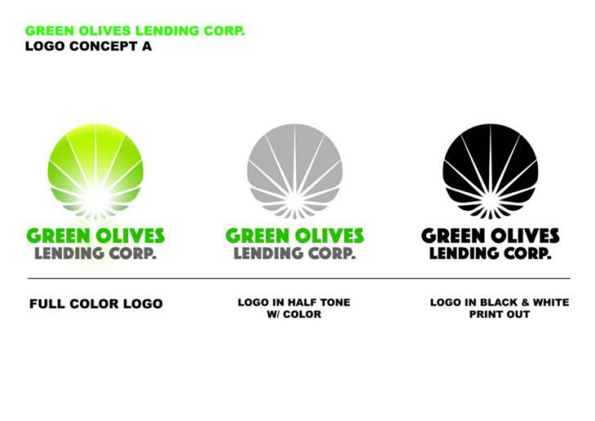
Green Olives Lending Corp.
4th Floor Vareb Mansion, Mabini St., Malate Manila
April 2018 – July 2020
ADMIN LOANS OFFICER / LEGAL OFFICER
- Officer In-Charge Cebu Branch
- Officer In-Charge Isabela Branch
- Officer In-Charge for Opening Branches in Provinces
- Officer In-Charge for Loan Collection
- Making Reports (Bank Transaction, Collection, Receivable, Cash on Hand)
- Company Representative for BP22 Cases
- Officer In-Charge in Making Legal Cases (Process for Municipal Trail Court for Small Claim cases in Clients.)
- Handling Petty Cash
- Handling Loans
- Processing Business Permit
- Process for BIR
- Assessing Clients
- Deposit and Withdrawal of Cash and Cheque
- Fund Transfer
- Interviewing Clients
- Interviewing Company Applicants (Customer Service)
- Marketing Clients
- Making for Radio Advertising
- Preparing Cheque
- Auditing and Monitoring Remittances and Manifest
- Advice and to Train the New Employee

CANTILAN BANK (A RURAL BANK)
Magosilom, Cantilan, Surigao Del Sur
September 2015 – May 2017

ACOUNT OFFICER
- Handling Loans
- Making Cash Flow Analysis
- Petty Cash
- Making Recommendation for Loans Client’s Applicant
- Marketing Client’s
- Making Reports, (Collection, Receivables, Cash on hand)
- Process Loan Releases
- Interviewing New Clients (Customer Service)
- Handling Writ – Off Clients
- Assessing Personal Collection in Client’s
- To Train and Advice, the New Employee

SEMINAR’s ATTENDED:
- Credit and Collection Seminar
March 16, 2019, Atlanta Centre
Annapolis St. Greenhill’s, San Juan
City, Metro Manila
Skills:
Communication Skills Determination
Data Entry Flexibility
Multi -Tasking Team Work
Problem Solving Leadership

CAREER OBJECTIVE:
Seeking a company where my experience can improve the status of the company but also to automate in the working process to the best possible as one.

CHARACTER REFERENCE:
Haide M. Lascuña (Loans Processor) 0936 453 9796
Lea Afable (Finance Manager) 0917 174 2104
Ruel C. Arcala (Bank Manager) 0998 991 5654
Cyril G. Boniao (Equipment Checker) 0915 550 3560

I hereby certify, that all the above information is true and correct to the best
of my knowledge and belief .

Human Resource Department

Dear Ma’am/Sir,
I have heard that your good office is in search of manpower. I believe that there would be a contribution between my skills and experience and your needs.
I am interested in applying for Non-Skilled Worker for Saskatchewan Canada. I am confident that my skills and experience could make a great contribution in the firm, and I am also willing to do extra work that you will give to gain more experience.

I can be reached anytime via email at kevintorcino95@gmail.com or my contact number
0909 271 4682.
I would appreciate the opportunity to discuss my qualifications for any of your vacant positions in greater detail with you in person at your earliest convenience. My resume is attached for your review.

Thank you for your consideration.

Respectfully yours,

KEVIN M. TORCINO
Applicant

