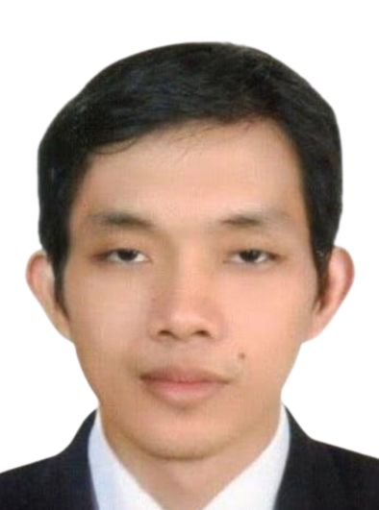
DANILO JR. BURCENA SANTIAGO

Attach Here
2x2
Colored Picture
425, Purok 1, Sampaloc, San Rafael
Bulacan, Philippines 1500
Phone No.: -
Mobile No.: +639452290885
Email Add: nyorsantiago25@gmail.com

BASIC INFORMATION

Gender : Male
Date of Birth : August 25, 1985
Age : 38
Birth Place : Baliwag, Bulacan
Marital Status : Married
Citizenship : Filipino
Height : 5’6.5 ft.
Weight : 120 lbs.
Religion : Church of the Living God
Passport Number : P2524883B
Passport Expiry : 2029-07-11

WORK EXPERIENCE

Position : WELDER
Company : BANANIA METAL WORKS
Address : 276 Purok 3, Sampaloc, San Rafael, Bulacan
Duration : April 08, 2020 up to present

Duties and Responsibilities:
- Read blueprints and drawings and take or read measurements to plan layout and procedures.
- Set up components for welding according to specifications (e.g. cut material with powered saws to match measurements)
- Operate angle grinders to prepare the parts that must be welded.
- Align components using calipers, rulers etc. and clamp pieces.
- Weld components using manual or semi-automatic welding equipment in various positions (vertical, horizontal, or overhead).
- Repair machinery and other components by welding pieces and filling gaps.
- Test and inspect welded surfaces and structure to discover flaws.
- Maintain equipment in a condition that does not compromise safety.

Position : MACHINE OPERATOR
Company : TYC BROTHER INDUSTRIAL CO., LTD
Address : 377 Bentian Rd. SEC. 2. Annan District Tainan City, Taiwan R.O.C.
Duration : From April 10, 2007 to March 30, 2009
From November 3, 2009 to October 22, 2012
From August 15, 2016 to February 11, 2020

Duties and Responsibilities:
- Operates 6 axis robotic machine (ABB and KUKA).
- set the heating machine to 130 degrees Celsius
- heat the robot needle with the torch.
- check the materials if there is a problem.
- start assembling the small parts using electric screwdriver.
- put the assembled parts on the jig and start to glue using the robot.
- place and press the lens into the glue.
- remove from the jig and place it on the press machine.
- put on air test machine to see if there is an air leak.
- Install bulbs and electrical wirings and test for lighting.
- Responsible for daily maintenance of the machine to prevent any damage to the item.
- Has the ability and skills in robot programming.
- Responsible for sorting out empty boxes from the working area and sending it outside.
- Responsible for writing a record of assembled work orders and give to the supervisor.

Position : INDUSTRIAL WELDER
Company : CAGAYAN CORN PRODUCTS CORPORATION
Address : FV Viola Diversion Road San Rafael, Bulacan
Duration : From June 2013 to August 2016

Duties and Responsibilities:
- Welding structural steel frames to support machinery and equipment in factories, warehouses, and other industrial settings.
- Reading blueprints, engineering drawings, or other written instructions to determine the type of weld needed for a particular application.
- Maintaining welding equipment such as torches, regulators, and grinders for optimal performance.
- Following safety procedures to protect themselves from injuries such as burns caused by exposure to extreme heat or electric shock from sudden shorts in the electrical circuit.
- Inspecting welds for defects such as cracks or gaps in the seams, which can cause the weld to fail Installing and repairing industrial machinery such as, boilers, pipe racks, or conveyor systems.
- Making minor repairs to weld equipment or tools to keep them operational.
- Cutting metal parts to size using shears or plasma cutters

TRAININGS / CERTIFICATION

- EL PLATAL TRAINING AND ASSESSENT SCHOOL INC. ( WELDER'S PERFORMANCE QUALIFICATION TEST)
- TESDA NC II (SHIELDED METAL ARC WELDING (SMAW)
- TESDA NC II (GAS METAL ARC WELDING (GMAW)

FAMILY DETAILS

Spouse’s Name : Santiago, Pearly C.
Birthdate : July 3, 1986
Highest Level of Education : BS Mass Communication
Civil Status : Married

Son’s Name : Santiago, Danilo III C.
Birth Date : October 9, 2009
Highest Level of Education : Grade 7
Civil Status : Single

EDUCATIONAL BACKGROUND

Elementary Year [From] - [To]
School: Sabang Elementary School 1992 - 1998
Address: Sabang, Baliuag, Bulacan

Secondary
School: Maguinao Cruz na Daan High School 1998 - 2002
Address: Maguinao, San Rafael, Bulacan

Tertiary
Course: BS AGRICULTURE (undergraduate) 2002 - 2003
School: BULACAN NATIONAL AGRICULTURAL STATE COLLEGE
Address: Pinaod, San Ildefonso, Bulacan

Vocational
Course: Computer and Electronics Communication Technology 2003-2005
School: Universal Institute of Science and Technology
Address: Mariano Ponce St., Poblacion, Baliuag, Bulacan

SKILLS

- Detail Oriented
- Machine Troubleshooting and Assembly
- Computer Literate
- Tile Setter
- Masonry
- Drywall Installer and Ceiling Installer

CHARACTER REFERENCES

Mr. Daniel Banania
Company Head
BANANIA METAL WORKS
Tel. No.: 09685374473

Mr. Allen Chang
Coordinator
TYC BROTHER INDUSTRIAL CO., LTD
Tel No.: +886921035282

Mr. Arron Coronel
Supervisor
Cagayan Corn Products Corporation
Tel. No.: 09953090712

DANILO B. SANTIAGO JR.
Applicant’s Signature

