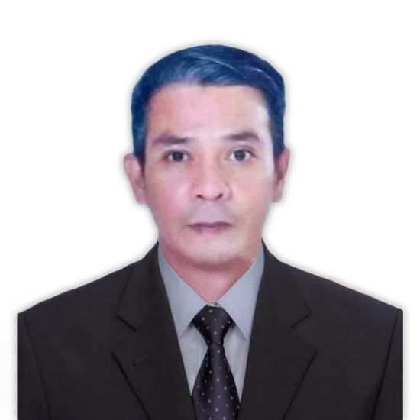

SKILLS & ABILITIES

- Manual Machinist/ Engine Rebuilding
- Hardworking & Dedicated

OBJECTIVES:

To get a stable job in a stable company and to elevate career. To be productive individual and to secure good future.

PERSONAL DATA:

Date of Birth :July 11, 1978
Marital Status :Married
Nationality :Filipino
Religion :Roman Catholic
Gender :Male
Age :45 y/o
Height :5’6 ft.
Weight :54 kgs.
Laguanges :English & Tagalog

GILBERT MANCARIÑAS
Sitio 4 Barangay Oogong, Santa Cruz, Laguna
Mobile No: (+63) 905 022 9279
E-mail Address: gilbertmascarinas0@gmail.com

WORK EXPERIENCE :

CARLOS DOMINGO MACHINE SHOP
Feb. 27, 2017- April 24, 2023
Manual machinist/ Engine Rebuilder
( Horizontal & Vertical Milling)

EFREN MACHINE SHOP
September 30, 2012 – February 20, 2016
Manual Machinist

KWIKWAY MACHINE SHOP
April 11, 1996 – 2000
Valve Setter/ Lathe Machine Operator

EDUCATIONAL BACKGROUND:

VOCATIONAL

2YRS AUTOMOTIVE TRADE SCHOOL

Secondary Education
AFG BERNARDINO MEMORIAL TRADE SCHOOL

Primary Education
PASOLO ELEMENTARY SCHOOL

CHARACTER REFERENCES:

Maricor Umabe
Sta. Cruz, Laguna
0910-822-8834

I hereby certify that the above information is true and correct any false information can subject me to remove me in your good work /office.

GILBERT MACARIÑAS
Applicant

