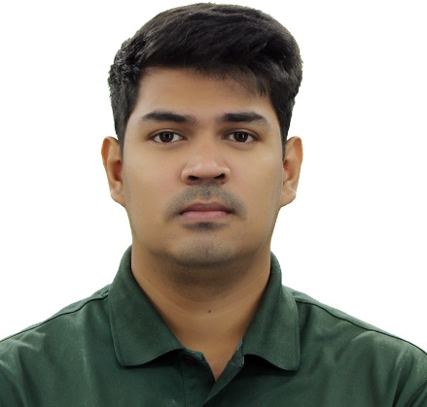
Karem B. Ramchand
Zone 2, Tebag West, Sta. Barbara, Pangasinan
Contact No. 09984539355
E-mail: karemchand0813@gmail.com

Objective:
To be part of a company where I can learn and share my knowledge and experience in the field.
Experience: Education:
HIPCAMP Central Pangasinan School of Technology
Lead Generation Specialist Electrical and Installation Maintenance NC II August 2021 - June 2023 September 2023 - October 2023

PANDYAN BOOKSHOP STI College Dagupan
Sales & Customer Service Associate Associate in Computer & Technology
November 2019 - March 2020 June 2013 - April 2015

WALTER MART NORTH EDSA Pevhee Izel School
Sales Clerk June 2009 - April 2013
January 2017 - August 2017

Ming Mei Cosmetics
Production Personnel
December 2015 – September 2016

Seminars Attended:

- Seminar on Effective Workplace Organization with 5’S
July 2016
Marites M. Rabelo, MBA
- Seminar on 13 Cosmetics Good Manufacturing Practice Modules
February 2016
Marites M. Rabelo, MBA

Personal Data:

Date of Birth - November 12, 1996
Place of Birth - Sta. Barbara, Pangasinan
Citizenship - Filipino
Civil Status - Single
Height - 6’1ft
Weight - 95kg

