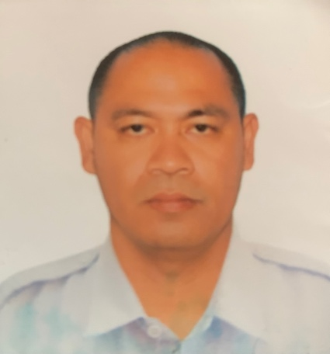
Able Bodied Seaman
PHONE: +639163903440
EMAIL: benjie068@gmail.com
ADDRESS: Inerangan Alaminos City, Pangasinan

SUMMARY
Able Bodied Seaman with 20 years’ experience in assisting in the maintenance operation at NCL Passenger Ship in a safe, efficient and effective manner, under the immediate supervision of the Ship Master.

SKILLS
Operating Machine-Like Mooring Winch, Anchor Winch etc.
Paint Decks, Tender Driver, Bridge Watch Duty.

WORK EXPERIENCE
AB HELMSMAN
Viking Cruises - 2022 - 2023 onwards
Helmsman & Day work duty’s.

2ND BOSUN
Norwegian Cruise Line – 2021 – 2022
Deck Supervisor

ABLE BODIED SEAMAN
Norwegian Cruise Line – 2008 – 2021
Responsible for using emergency, lifesaving, damage control, and safety equipment on a merchant ship, performing general maintenance, repair, and sanitation duties, and standing watch to ensure the ship maintains a steady course.

ORDINARY SEAMAN
Norwegian Cruise Line – 2004 – 2008
Responsible for the smooth operation of most occurrences above deck. Capable of performing and supervising almost any task in connection with deck maintenance, small boat operations, and navigation.

DECK BOY
Norwegian Cruise Line – 2003 – 2004
Responsible in carrying out the tasks and responsibilities assigned by the Bosun with regards to the ship's maintenance. Assists the Officer of the Watch, when assigned to watch keeping duties.

EDUCATION
PANGASINAN MERCHANT MARINE ACADEMY
Bachelors in Science in Marine Transportation
June 1997 – March 2000

CHARACTER REFERENCES

Mr. Jikie Ilagan
Fleet Manager
Tel: +632 527 6031 to 49 loc 254/262
E-mail: jpilagan@cfsharp.com

Lawrence Francia
Fleet Manager
Phone / Fax: +632 527 6031 to 60 loc 254/110
E-mail: llfrancia@cfsharp.com

Captain Richard Svardmark
Rsvardmar@gmail.com

