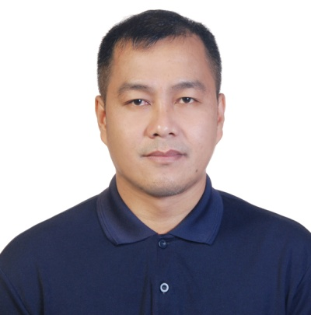
BONIFACIO M. BAUTISTA JR.
#230 San Blas Villasis, Pangasinan
Contact Number: +639912414693/ +639217524165
E-mail: bonifaciojr.bautista@yahoo.com

OBJECTIVE:
To apply as a General Machinist/CNC Machinist or any vacant position that suits my experiences.

CAREER OBJECTIVE:

- To secure a challenging position in a reputable organization to expand my learning, knowledge and skills.
- Secure a responsible career opportunity to fully utilize my training and skills while making a significant contribution to the success of the company.
- To secure employment with a reputable company where I can utilize my skills.
- A highly organized and hard working individual looking for a responsible position to gain practical experiences.

PERSONAL DATA:

Nick Name : Jhay-Ar
Age : 38
Date of Birth : February 19, 1985
Place of Birth : San Blas, Villasis, Pangasinan
Civil Status : Married
Height : 173cm
Weight : 79 kg.
Citizenship : Filipino
Sex : Male
Computer Skill : Ms Word, Excel and Power Point

EDUCATIONAL BACKGROUND:

Tertiary : University of Pangasinan
Bachelor of Science in Commerce
Dagupan City
October 2008

Secondary : Don Ramon E. Costales Memorial National High School
Villasis, Pangasinan
March 2003

Primary : San Blas Villasis, Pangasinan
Villasis, Pangasinan
March 1998

WORK EXPERIENCES:

Taroko International Co., Ltd
#263, Her- Jen Rd., Sec. 1,Jen- Te, Tainan City 717,Taiwan R.O.C
General Machinist/Mold Setter
August 2013- February 2023

Duties and Responsibilities:

- Install mold and remove them from the injection molding machine.
- Install necessary water lines, knockout bars, hydraulic bars, hydraulic lines, air lines, switches hoppers , dryers and auxiliary equipment.
- Perform relief duties; fill in for the positions as required.
- Lifted crane operator.
- Responsible for monitoring, maintaining and operating safety procedures.
- Feeding raw material to the machine.
- Perform quality control and report problems to the supervisor.
- Maintain cleanliness in working area.

Ho-Hong Precision Tools Co., Ltd
No. 14, Xinmin Rd., Luzhu Shiang, Kaohsiung County 821, Taiwan R.O.C
General Machinist/ CNC Operator
-Milling, Grinding, Threading
August 29, 2010- May 9, 2012

Duties and Responsibilities:

- Preparing of tools to measure like micrometer, calipers, micro dial and microscopic meter to examine parts and measuring products.
- Prepare and load raw materials on the machine.
- Studies drawing or sketches sample to determine the dimension and set up requirements.
- Aligns and secures hokling fixture, cutting tools and material on machine as required.
- Calculate and sets controls to regulate machine factor such as speed, feed, coolant flow, and angle of cut.
- Setting up machine on trial to verify accuracy of machine settings or programmed control.
- Verifies of finished work piece to specifications using measuring tools.
- Supervise the machines while they execute the tasks and make any necessary adjustments to a product for a better result.
- Maintain a clean and organized work area.
- Maintain accuracy of all equipment like measuring tools.
- Follow the rules and regulations at work areas.

Rusi Ram Cycle Company
Registration In-Charge
San Vicente Urdaneta City, Pangasinan
December 1, 2009 -February 1, 2010

Duties and Responsibilities:

- Collected all documents of a new motorcycle.
- Comparing documents, body number, chase number and verify if it’s the same to the documents
- Preparing documents for Land Transportation Office (LTO).
- In-Charge for releasing Original Document such as Official Receipt (OR) and Certified Receipt (CR).

Corfarm Bank
Field Collection Manager
Rosales, Pangasinan
2008-2009

Duties and Responsibilities:

- In-Charge to the lending collection of the bank.
- In- Charge of Collecting Information (CI) of the barrower.
- Supervise all collectors to perform their duties at the field.

SPECIAL SKILLS:

- Forklift Operator (Manual and Automatic)
-Excavator Operator
-Elf Driver

CHARACTER REFERENCES:

Wang Lee Ming Yang
General Manager
Taroko International Co., Ltd
Tainan, Taiwan

Michael Shi
Broker (Consultant)
Geo Chung Management Consultants Co., Ltd
Kaohsiung City Taiwan

Wang Chih Wen
Office In-Charge
Ho Hong Precision Tools Co., Ltd.
Kaohsiung City Taiwan

BONIFACIO M. BAUTISTA JR.
Applicant

