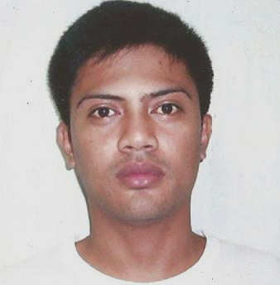
Darvin Planta Paculan
Contact #09954652611
Email: darvin_p@yahoo.com.ph
darvinpaculan@gmail.com

Position Desired:
Any Position that will fit on my skills, work experiences
And capabilities.
High Lights:
- Works well under pressure.
- Highly responsible and reliable.
- Can understand and communicate in English.
- Willing to undergo trainings and seminars.
Objective:
- To be able to find a job that suites my skill and capability that will enhance my knowledge and experience.

ADDRESS: Ordona St. Poblacion East, Rosario La Union Ph 2506
Birthday: August 22, 1986
Sex: Male
Height: 5”6
Weight: 155 Lbs.
Status: Married

Educational Attainment:

- Primary: Rosario Central School (1990-1996)

- Secondary: Saint Mary’s Academy (1997- 2000)

- College: DATA CENTER COLLE OF THE PHILIPPINES (2001-2003)
B.S COMPUTER TECHNOLOGY

UNIVERSITY OF CORDILLERA (2003-2006)
B.S NURSING (Undergraduate)

Work Experience:

- ComWorld Computer Shop (2008-2009)
COMPUTER TECHNICIAN AND MAINTENANCE

- PAGASA LENDING COMPANY (2009-2010)
DEVELOPMENT OFFICER

- TULAY SA PAGUNLAD INCORPORATED (2010-2016)
ACCOUNT OFFICER
- ECUMENICAL CHURCH FOUNDATION ( 2016-2017)
PROGRAM OFFICER
- PAMPANGAS BEST INC. ( 2017- 2018)
CHECKER

SEMINARS:
  - FOOD HANDLING AND HOUSEKEEPING
  - ACCOUNT MANAGEMENT AND HANDLING (Micro financing)
  - Standard Client Investigation and Business Inventory Checking (CI/BI)
  - Proper Client marketing strategies.
  - PAR Reduction Management.
  - POLARIS Operating System Module.
  - Agricultural & Livestock Loan Assessment Approval

Training /Skills:
- Computer Literate (Trouble Shooting Software and Hardware, Encoding)
- Driving (Manual/Automatic)
- Cooking (Filipino foods, Dishes and Delicacies)

Additional Information’s and identifications:
  - SSS, Phil health, Pag-Ibig Member.
  - Non Pro Driving License
  - NSTP Graduate
  - Passport

Character References:
Emmanuel Ugay
Lawyer

SBM. Florante Zarate
Rosario La Union

Jean D. Basco
Manager Rural Bank of Rosario

I hereby certify that all the information and statements above are valid and true.

Darvin P. Paculan
Applicant

