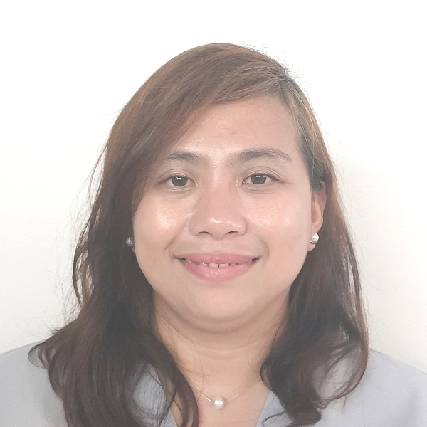
JEANNE RHEA V. LAWAS, RN, OHN
PRC License No.0786618
Canlingo, Sabang, Danao City
0949-4695704/09661836613 jeannerheav@gmail.com

CAREER OBJECTIVES To join a company where my qualities and my abilities to take and absorb new challenges shall be used.
To use my potentials and capabilities to the company I shall be connected with.
PERSONAL DATA
Age : 37 years old
Date of Birth : February 1, 1986
Civil Status : Married
Citizenship : Filipino

EDUCATIONAL BACKGROUND

Tertiary : University of San Jose-Recoletos
Bachelor of Science in Nursing
2004–2008

: University of San Jose- Recoletos
Bachelor of Arts in LIACOM
Major in Mass Communication and Marketing
2003-2004

Secondary : University of the Visayas
1999-2003
Graduate

Elementary : Mabolo Elementary School
1993-1999
Graduate

WORK EXPERIENCE

October 12, 2020- Present : Staff Nurse
Minebea Mitsumi Incorporated
MRI Special Economic Zone, Danao City

Responsibilities:
- Provides emergency and palliative care and treatment to all employees within the legal scope of nursing responsibility in the absence of the company physician. This includes first-aid, checking vital signs, health interview, dispensing of medicines etc.
- Assess patients upon clinic entry, provide bedside care, administer medications and intravenous infusion as per doctor’s order, referral to laboratory and endorse employee to hospitals.
- Transports ill and injured employees to hospital or home and manages patient in the absence of a company physician
- Sends notice for patients who have findings with their Annual Physical Exam and ask them to report to clinic for follow up check up
- Facilitates lectures for newly on-boarded employees for clinic procedures, Family Planning program and Basic Occupational Safety and Health, Drug free Workplace Program and Ergonomics Program
- Prepare Annual Medical Report for submission and Government compliance
- Cater employees needs regarding their filed sick leave and maternity leave
- Renders home visit and provide necessary care treatment
- Check process where accident occurred
- Monthly reporting on Work related accident and its expenses
- Safety inspection at clinic
- Conducts periodic plant inspection to prevent health and safety hazard and create safety awareness among employees
- Conduct orientation for refresher courses for new nurses and staff
- Makes Statistical Report of the over-all Clinic Transactions/Monthly Reporting for Management Review presentation.
- Prepares and sterilizes surgical instruments, assist doctors for minor surgery as a result of Work Related Accidents.

Nov. 1, 2013 – May 30, 2020 : Company Nurse/HR Staff
Phil. Medical Support Research Development Corp
Osmeña Blvd, Cebu City

Responsibilities:

- Physical Assessment of newly-hire employees
- Administration of OTC medications
- Visited and evaluated safety at job sites
- Managed non-occupational illnesses and injuries
- Performing day-to-day administrative tasks such as maintaining information files and processing paperwork
- Monitoring absences in the worksite
- Maintain workers' compensation files and reports
- Process employee benefits and contributions
- Payroll computation and distribution
- Reviews company policies and guidelines to newly-hire

Jul. 16, 2012 – Oct. 19, 2013 : Company Nurse
Cebu General Services Incorporated assigned at Cebu Mitsumi Incorporated
A. S. Fortuna St., Mandaue City

Responsibilities:

- Assess and provide high-quality nursing care to employees
- Delivering first aid, V/S monitoring, IVF insertion, giving prescribed medication
- Orientation of newly hired employees about clinic services and health program
- Treated work-related injuries and designed care plans
- Establishing long-range objectives and specifying the strategies and actions to achieve them
- Scheduling events, programs, and activities
- Giving lectures on promoting health and wellness
- Prepare audit reports as well as periodic status reports to management
- Maintain clinical records in compliance with laws and regulation
- Make monthly report on contagious diseases

Nov. 1, 2010 - Apr. 30, 2012 : Customer Service Representative
Qualfon Philippines, Incorporated
9th Floor Skyrise 3 Building, Asiatown IT Park
Lahug, Cebu City 6000 Philippines

Responsibilities:

- Resolves customers complaints via phone
- Identifying and assessing customers’ needs to achieve satisfaction
- Build sustainable relationships of trust through open and interactive communication
- Provide accurate, valid and complete information by using the right methods/tools
- Handle complaints, provide appropriate solutions and alternatives within the time limits; follow up to ensure resolution
- Keep records of customer interactions, process customer accounts and file documents
- Follow communication procedures, guidelines and policies

SEMINARS / TRAININGS ATTENDED

MENTAL HEALTH PSYCHOSOCIAL SUPPORT TRAINING
Mental Health Consultant (Abelardo Banuag)
Minebea Mitsumi, Sabang, Danao City, Cebu, Philippines
September 27-29, 2023

DEVELOPING SELF AWARENESS IN LEADERSHIP TRAINING
Mental Health Consultant (Abelardo Banuag)
Minebea Mitsumi, Sabang, Danao City, Cebu, Philippines
September 19-21, 2023

POST GRADUATE COURSE ON BASIC HEALTH PROMOTION
College of Public Health
University of the Philippines-Manila Seameo Tropmed
Philippines (Via Zoom)
May 15-26, 2023

STANDARD FIRST AID AND BASIC LIFE SUPPORT CPR W/ AED TRAINING
Philippine Red Cross- Cebu Chapter
Jagobiao, Mandaue City, Cebu
Mar 15-18, 2023

FIRST AID AND BASIC LIFE SUPPORT TRAINING
(Industrial Setting)
Minebea Mitsumi Inc, Danao City
May 27, 2022

BASIC OCCUPATIONAL SAFETY AND HEALTH
(BOSH) Training for Nurses via Online Platform
Minebea Mitsumi Inc, Danao City
April 4-9, 2022

ISO 9001:2015 Awareness Training
Minebea Mitsumi Incorporated
Danao City, Cebu
December 2, 2021

FIRST AID TRAINING FOR INDUSTRIAL SETTING
Philippine Red Cross
Cebu Mitsumi Inc, Danao City
November 27-28, 2012

BASIC LIFE SUPPORT (CPR)
Philippine Red Cross
Cebu Mitsumi Inc, Danao City
November 26, 2012

CERTIFICATES/RECOGNITION:

2023 MEDICAL MISSION VOLUNTEER
MRI Special Economic Zone,
Sabang, Danao, City
November 19, 2023

“OPERATION TULI’ VOLUNTEER
MRI Special Economic Zone,
Sabang, Danao, City
July 15, 2023

“2023 MEDICAL MISSION PLUS” VOLUNTEER
Guinacot Integrated School
Brgy. Guinacot, Danao City
February 19, 2023

SPECIAL SKILLS

Good oral and written communication skills
Have adequate proficiency in Word, Excel and Power Point computer programs.
Proficient in reports preparation
Ability to take notes and minutes of the meeting

CHARACTER REFERENCES:

DR. MARILYN CASTILLO
Company Physician
Minebea Mitsumi
+63 932 246 7081

FILNA DIANA M. GOMEZ
Pharmacist/ Assistant Supervisor
Minebea Mitsumi
+63 908 619 3823

MR. IRENEO MILDRED TANGALIN
HR- MANAGER
Minebea Mitsumi
+63 917 7092819

