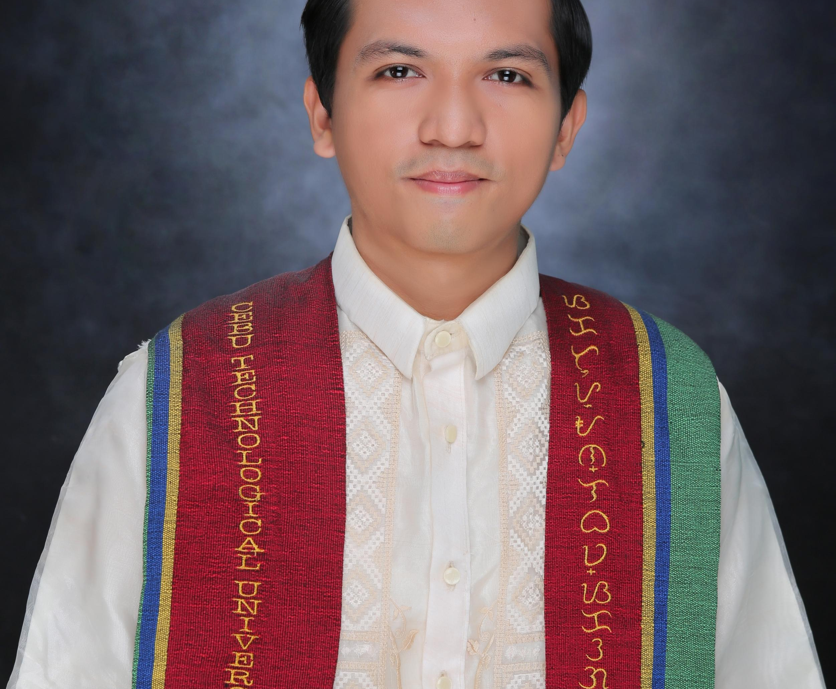
Vencent L. Roca
Phone: 090661822243
Email: vencentroca27@gmail.com
Address: Cogon Guinsay Danao City, Cebu

CAREER OBJECTIVE
To work in a dynamic environment that enables me to utilize my knowledge and skill and learn new things to progress professionally and personally.
TECHNICAL SKILLS
- Hardware maintenance and troubleshooting
- Software Installation (Windows, Applications, etc.)
- Productivity Softwares (MS Word, Excel, Powerpoint, Internet, etc)
PERSONAL SKILLS
- Highly organized and efficient
- Ability to work independently or as part of a team
- Proven leadership skills and ability to motivate
PERSONAL PROFILE
Gender : Male
Date of Birth : April 11,1995
Marital Status : Single
Height : 5’4”
Weight (Kg) : 55kg.
Nationality : Filipino
Religion : Roman Catholic
EDUCATION
Bachelor of Science in Industrial Technology
Major in : Computer Technology
Cebu Technological University – Carmen Campus
Poblacion, Carmen, Cebu
(2019-2023)

Guinsay National High School
Guinsay Danao City
(2008-2012)

Guinsay Elementary School
Guinsay Danao City
(2004-2008)
WORK EXPERIENCE
(CEBU MITSUMI INC.) Menibea Mitsumi Inc.
Sabang Danao City, Cebu
(Aug.2013-June2021)
- Cleaner/Cleantech Cleaner

ADSCO Enterprise (On-The-Job Training)
Nasipit, Talamban Cebu City 6000
(1,800 Hours)
- Installing Operating System and Microsoft
- Troubleshooting PC
- Pull outing Units

CHARACTER REFERENCES
Mr. Benvienedo Tudtud
Manager
ADSCO Enterprise – Nasipit, Talamban Cebu City
09176332933

Mr. Noel Bionson
Supervisor
Cebu Mitsumi Inc.
09178423004

I hereby declare that the information furnished above is true to the best of my Knowledge.

Vencent Libradilla Roca
Applicant

