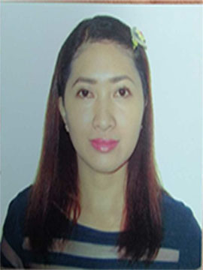
BRENDADETTE C. OPADA
Address: Villa Purita, Pakigne Minglanilla Cebu City
Contact No: 09477829920
Email : Brenda.dette2018@gmail.com Facebook:Brendadette Cabusas Opada
PERSONAL DATA:
Age: 36
Height: 5’2”
Weigth: 120 lbs.
Birthday: October 17, 1986
Religion: Roman Catholic
Father’s Name: Daniel A. Opada
Mother’s Name: Bernarditha C. Opada

EDUACATIONAL ATTAINMENT:
College:
University of Cebu 2003 - 2006
Sanciangko St. Cebu City
Course: BSIT
Secondary:
Aurora National High School
1999 - 2003
Aurora, Zamboanga Del Sur
Primary:
Aurora Regional Pilot School
1993 - 1999
Aurora, Zamboanga Del Sur

ORGANIZATIONAL AFFILIATION:
IT – CESDEV NCII – SEWER

WORK EXPERIENCES:
2006-2021 (online seller and real estate agent)

2019-2020
Property Specialist
Robinsons Land Corporation
Robinsons Galleria Cebu

Chipmos Technology Machine Operator
Tainan, Taiwan July 2014 – March 2016

Landmark Marina Hotel Waitress / Receptionist
Koror, Palau Nov. 2011 – Nov. 2012

SM Appliance Sales Clerk
SM City Cebu Jan. 2010 – March 2010

Shakey’s Food Attendant
Fuente Osmeña, Cebu March 2008 – Jan. 2009

Nonki Japanese Restaurant Food Attendant
AS Fortuna, Mandaue City Sept. 2007 – Feb. 2008

REFERENCES:

Jesselou Misa
School Registrar
Manila Central University

Ivy Joy Mariquit
Accountant
Apple Asia Singapore

