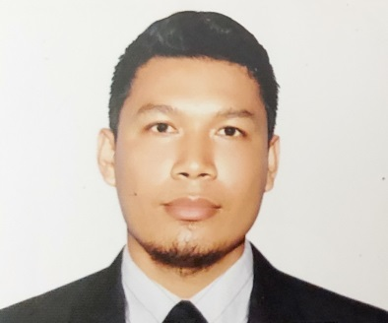
JORDAN M. LONGHENO
Blk. 4 Lot 8 Phase 2 Mater Dei St. Del Mundo Subd.
Llano Rd. Brgy. 167 Caloocan City 1420 Phils.
Mobile No. +63943135122
Email Add: longheno.jl@gmail.com

EMPLOYMENT OBJECTIVES:
Seeking a challenging opportunity where I can utilize my strong organizational skills and ability to work well and professionally. I consider myself as a dedicated and independent worker.
WORK SUMMARY:
  - Five years experienced in electronics company on Taiwan, specialized in full range TFT LCD panels, module and touch panels, including TV panels, Desktop Monitors, Notebook Computer panels, Small and Automotive panels.
  - Two years experienced in Gas Tank fabricator as welder.
WORKING EXPERIENCES:
Machine operator
Innolux Corporation
No. 3 Sec. 1 Huansi Rd. Southern Taiwan Science Park
Tainan Count 741147, Taiwan R. O. C.
Tel. no. +886-6-5051888
September 26, 2013 – May 05, 2015

Machine Operator And Warehouse Packaging
Innolux Corporation
No. 3 Sec. 1 Huansi Rd. Southern Taiwan Science Park
Tainan Count 741147, Taiwan R. O. C.
Tel. no. +886-6-5051888
September 10, 2015 – August 27, 2018

Welder
Ferrotech Steel Corp.
#28 Malinis Rd. Valenzuela,
Metro Manila
Tel. no. 0284038888
September 19, 2019 – September 21, 2021

Major Responsibilities are:
- Set up machinery and ensure all materials readily available.
- Perform appropriate duties as assigned by management and follow established safety rules and regulation.
- Making sure that the machines are fully working at full capacity and well-maintained.
- Carry out production inspection, packaging and machine operator duties.

PERSONAL PARTICULARS:

Date of Birth : Febuary 17, 1985
Place of Birth : Caloocan City
Age : 36 years old
Marital Status : Married
Height : 174 cm
Weight : 1176 lbs.

EDUCATIONAL ATTAINMENT:

VOCATIONAL :

Xavier Technical Training Center
Computer Hardware Services
2011

Cebu Science of Welding and Skills Technology, Inc.
Shielded Metal Arc Welding (SMAW) NC II
May 06, 2019 – June 18, 2019
Flux Cored Arc Welding (FCAW) NC II
June 28, 2019 – August 06, 2019
Gas Metal Arc Welding (GMAW) NC II
October 10 2019
1081 – A Quirino Highway, Brgy. Kaligayahan, Novaliches, Quezon City, Phils.

SECONDARY:

Aringin National High School
Aringin Moncada Tarlac
1997-2002

PRIMARY:

Moncada Catholic School
Moncada Tarlac
1991-11997

