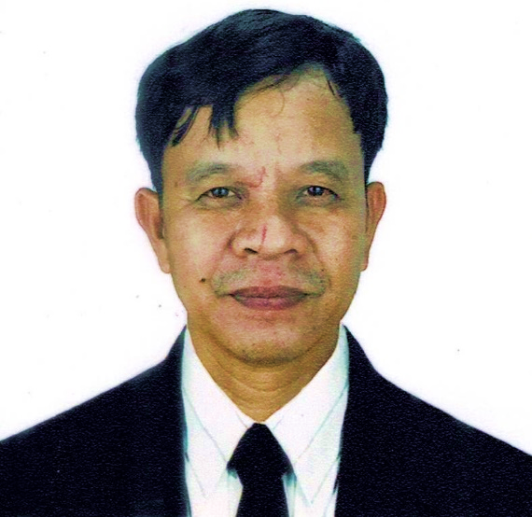

ROLANDO R. HORTIZUELA
CABINET MAKER/CARPENTER
Total Experience Abroad: Total Experience Local: 13 Years

To use my skills that would best fit my qualification and develop my talents and benefits for continuous career development.

WORK EXPERIENCE:

POSITION : CABINET MAKER
DATE EMPLOYED : 2020 up to present
COMPANY DETAILS : CUSTOM FURNITURE
Name : 0710 Wood Works
Address : Brgy. Palali Norte, Sta. Lucia, Ilocos Sur
Philippines

DUTIES AND RESPONSIBILITIES

- Cabinet Maker and Installer
- Used hand tools and production equipment to perform furniture assembly
- Preparing and refurbishing old furniture
- Assembled and install furniture and cabinetry
- Shape or cut materials to specified measurements using hand tools, power saws and machines.
- Build, repair and install custom cabinetry according to customer specification.
- Preparing or interpreting drawings or blueprints.
- Fits handle, hinges, locks, shelves, drawer guides and drawers, doors.
- Reviewing drawings and choosing appropriate materials like; synthetic board, veneers, timbers and plyboards.
- Sanding to smooth wooden surface and applying stain or veneers on polish to finished products.
- Used personal protective equipment such as: hearing protection, respirators, face shields, goggles, gloves and shoe cover or steel toe boot.
- Follows established rules and regulations to prevent any incidents
- Work under pressure
- Make sure that the piece of stock doesn’t have existing nails, screws or other piece lodged into it already.
- Disconnect the power source before changing blades or bits on power tools to avoid accident.

POSITION : CARPENTER
DATE EMPLOYED : 2016-2020
COMPANY DETAILS : PRIVATE CONSTRUCTION
Name : FREELANCER
Address : Sta. Lucia, Ilocos Sur, Philippines

DUTIES AND RESPOSIBILITIES:

- Installing wooden structures such as: roofing frames, rafters, partitions, joist and stud work.
- Designing and installing of cabinets, shelving, fitted furniture, drywall and installation.
- Adding fixture and fitting such as: door handle, locks, hinges and closures.
- Selecting lumber and fasteners required for each job.
- Reading blueprints and design to work to specification prepared by architect or engineers.
- Build and fixing of formworks.
- Responsible to check materials delivered.
- Responsible to use PPE or personal protective equipment such as: boot, hard hat, high visibility clothing, harness and other protective equipment.
- Follow rules and regulations for safety to avoid incident.

POSITION : CABINET MAKER/CARPENTER
DATE EMPLOYED : 2009-2016
COMPANY DETAILS : MODULAR CABINET AND GRANITE SPECIALIST
Name : 447 Enterprises
Address : National Highway, Brgy. Tablac, Candon City
Ilocos Sur, Philippines

Duties and Responsibilities:

- Reviewing, drawing and choosing appropriate materials such as: timbers, synthetic board, veneers and plyboards.
- Studies specifications in drawing of cabinet plans; work orders, sample parts to prepared fabricate and determine dimension.
- Preparing or refurbishing old furniture.
- Refining and enhancing existing furniture by adding intricate details.
- Operating wood working machine and using hand tools to cut shape and form wood.
- Build or repair cabinet doors, doorframes, shelves and cabinets.
- Fits cabinet doors, drawers, drawer’s guide shelves, locks and handles.
- Fitting parts together using glue and clamps.
- Reinforcing joints using nails and screws.
- Cutting and joining wood to make parts according to details.
- Sanding wooden surface and applying stain veneers or polish to finished products.
- Making cabinetry and furniture pieces according to specifications including hinges, locks, shelves, handles and drawers.
- Follows establishes safety rules and regulations and maintaining a safe and safety environment to prevent any incident.
- Using PPE or personal protective equipment like: goggles, gloves, hearing protection, face shield, mask and other protective equipment.
- Cleaning workplace, hand tools, power tools and machinery to maintain the cleanliness of the tools and the facility and organize hand tools as well after works.
- Repair minor damage of hand tool, power tools and machinery
- Standing to do work, bend, lift, climb using ladder and working in noisy, hot, dusty environment of work.
- Helping load and unload materials or finished products to delivered.
- Always remember to disconnect the power source before changing blades or bits.

PERSONAL INFORMATION:

Age : 44 years old
Date of Birth : August 25, 1979
Place of Birth : Sta. Lucia, Ilocos Sur
Civil Status : Married
Citizenship : Filipino
Height : 165 cm
Weight : 63 kg
Religion : Roman Catholic
Gender : Male
Cellphone No. : +639662200216
Email : hortizuela.vilog082579@gmail.com

EDUCATIONAL BACKGROUND:

VOCATIONAL : MT. PROVINCE INSTITUTE OF TECHNOLOGY INC.
: Baguio City
: S.Y. 1996-1997

SECONDARY : Sta. Lucia Academy
: Sta. Lucia, Ilocos Sur
: S.Y. 1992-1996

PRIMARY : Sta. Lucia North Central School
: Sta. Lucia, Ilocos Sur
: S.Y. 1986-1992

CHARACTER REFERENCE:

NAME : Robert Abaya
POSITION : Brgy. Council
CONTACT NUMBER : +639772618342

I hereby certify that the above information is true and correct to the best of my knowledge and belief.

ROLANDO R. HORTIZUELA
Applicant

