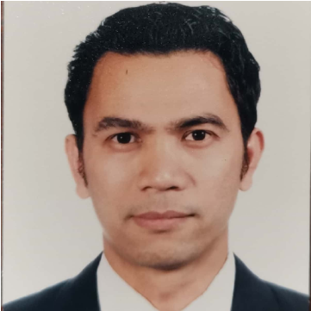
Jonnel M. Labay
Greengate Homes, Imus Cavite
Mobile No: (+63) 09394127477
Email Address:labayjonnel2@gmail.com

Objective: To obtain a position as a barkeeper where my strong dedication to bartending and customer service, as well as a high degree of enthusiasm, will be fully utilized to contribute to the company’s success. Poised to ensure customer satisfaction through delivery of well-placed bar food and beverage services.

Experience:

Barkeeper (AIDA)
April 2019-Present
Responsibilities:
- Overall in charge for bar or restaurant assigned by Bar Manager
- Prepare alcohol or non-alcohol beverages for bar and restaurant patrons
- Interact with customers, take orders and serve snacks and drinks
- Assess customers’ needs and preferences and make recommendations
- Mix ingredients to prepare cocktails
- Plan and present bar menu
- Restock and replenish bar inventory and supplies
- Comply with all food and beverage regulations
Junior Barkeeper (AIDA)
March 2018-January 10, 2019
Responsibilities:

- Professional preparation and mixing of cocktails and drinks according to standards
- Attend guests needs by providing a courteous, friendly, quick and professional service at all times
- Provide the highest level of comfort and sales-oriented service to guests
- Ensure the daily mise-en-place for all areas of responsibility
- Comply with all safety, security, environmental and hygiene requirements

Bar Waiter (AIDA)
March 2017-December 2017

Responsibilities:
- Performing, welcoming, and sales-oriented F&B Service
- Responsible for serving food and beverages in any F&B outlet according to the management
- Up-selling the menu to the guests efficiently
- Polishing equipment, glassware, and flatware
F&B Utility (AIDA)
March 2016-December 2016

Responsibilities:
- Properly serve food and beverages as per standards
- Responsible for cleanliness and maintaining the entrusted serving equipment
Room Service Waiter
September 2011-October 2014
Abu Dhabi

Responsibilities:

- Set tables, trays according to type of food ordered and the hotels service standards.
- Performs opening and closing procedures established for the department.
- Accurately records, pre-checks and picks-up all food and beverage orders.
- Check in with guests to ensure satisfaction with each food course and/or beverages.
- Responsible for cleaning and removing the trolleys/trays from guest rooms and corridor.
- Serves guests their food and beverage in prompt, courteous manner as per the standard sequence of service.
Achievement and Awards:
- Employee of the Month
- Promotion
- Financial Appreciation for my Performance
Skills:
- Excellent knowledge in mixing, garnishing and serving drinks
- Positive attitude and excellent communication skills
- Ability to keep the bar organized, stocked and clean
- Ability to accept criticism and work well under pressure
- Great Guests service skills
- Ability to create unique drinks
Trainings:
Basic Training (60 Hours)
- Personal Survival Techniques (IMO Model Course 1.19)
- Fire Prevention & Fire Fighting (IMO Model Course 1.20)
- Elementary First Aid ((IMO Model Course 1.13)
- Personal Safety and Social Responsibility
Education:
Hotel and Restaurant Management
John Bosco Academy
2006-2008

