CURRICULUM VITAE
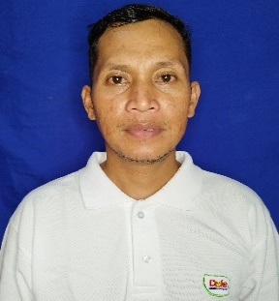

HAROLD ROYO ZAMORA
09971047935
haroldroyozamora26@gmail.com

EDUCATIONAL BACKGROUND:

Tertiary:
Two-Year Electronics Service Technician
Davao Northphil Institute of Tagum City
Pioneer Avenue, Mankilam, Tagum City, Davao del Norte
March 2003

Secondary:
Kimamon National High School
Kimamon, Sto. Tomas, Davao del Norte
March 2000

Elementary:
Talomo Elementary School
Talomo, Sto. Tomas, Davao del Norte
March 1996

WORK EXPERIENCES:

Inclusive Dates : 2017 – Present
Position Title : Butcher/ Slaughter man
Company : Cirilo O. Varquez- Tagum Public Market (Meat Section)
Tagum City, Davao del Norte

Inclusive Dates : 2015 -2016
Position Title : Leadman- Banana Manage Farm
Company : DOLE Stanfilco Philippines
Inclusive Dates : 2010 - 2014
Position Title : Banana Quality Assurance
Company : DOLE Stanfilco Philippines

Inclusive Dates : 2005 - 2009
Position Title : Rice Field Inspector
Company : Sterling Company

CHARACTER REFERENCES:

Cirilo O. Varquez
Meat Dealer Owner
Stall No. 437 Tagum Public Market
Tagum City, Davao del Norte
Mobile No. +639105297247

Leonardo G. Briones Jr.
Slaughter Master IV
Slaughter/ TLAC Division
Tagum City, Davao del Norte
Mobile No. +639267171459

Jesus G. Edulantes, DVM, MS
City Veterinarian
Skills Training Instructor
Tagum City, Davao del Norte
Mobile No. +639275313456

