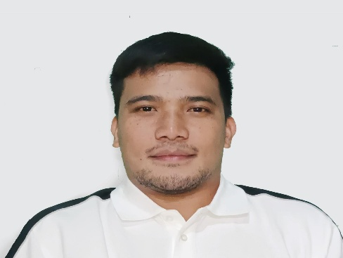
Rondex Calica Codiing
Brgy. Pudoc, Bauang, La Union
Email Address: rcodiing57@gmail.com
Mobile #: 09922812864/09319279610
OBJECTIVE: To secure job position based on my qualification or any related field that would hopefully lead to opportunities and to do assigned job as best as I can.
HIGHLIGHTS OF KNOWLEDGE:
- Electrical Wiring Installation and Maintenance
- Computer Literate
- Communication Skills (Written and Oral)
- Willing to be trained
PERSONAL INFORMATION:
- Place of Birth: Pudoc, Bauang, La Union
- Date of Birth: November 07, 1991
- Age: 32
- Civil Status: Married
- Sex: Male
- Nationality: Filipino
- Height: 5’5
- Religion: Roman Catholic
- Language: Ilocano, Tagalog, English, Chinese (Mandarin)
EDUCATIONAL BACKGROUND:
- Elementary: Parian Este Elementary School
School Year 2003-2004
- Secondary: Don Eulogio de Guzman Memorial National High School
School Year 2004-2008
- Tertiary: Don Mariano Marcos Memorial State University
(BS Electro Mechanical Technology, Undergraduate School Year2012-2013)
- Technical Vocational: Technical Education and Skills Development Authority
(Electrical Wiring Installation and Maintenance TRADE TEST PASSED 2015)

WORKING EXPERIENCE:
- NEC/TOKIN Electronics (Philippines) Inc. (Production Department , Production Operator)
May 2014 – October 2014

- LA UNION ELECTRIC COMPANY, INC. (Engineering Services Department, Junior Lineman)
March 2016-August 2016

- COMARK INC (Merchandiser)
August 2016-February 2017

- LIAN HWA FOODS PRODUCT INCORPORATED LTD TAIWAN (Machine Operator)
May 2018-September 2021

I hereby certify that the above information is true and correct to the best of my knowledge and belief.

Rondex Calica Codiing
Applicant

