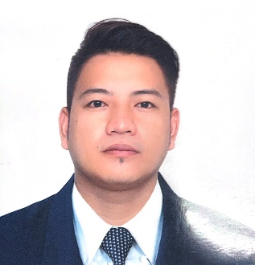
Aljon Pamintuan Vinuya
Address: Mapaniqui, Candaba, Pampanga 2013, Philippines
Email Address: aljonvinuya2018@gmail.com
Contact number: +63 9563445743

PROFESSIONAL SUMMARY
Restaurant Manager with over 13 years of experience working in a sea-based French Cruise Company. I started as a Waiter and have been promoted as the Restaurant Manager after 9 years of hard work and dedication in the same company. I am seeking my relevant position in your company where my knowledge and skills from my experience would be in great use and to obtain a job where I can maximize my fullest potential to contribute and meet the company’s goal and ideas.

WORK EXPERIENCE
Restaurant Manager Sea-based
2019 – present
- Knowledge in Food and Beverage Management
- Provided positive, high-energy and teamwork among subordinates, co-workers, and management.
- Provided guidance and direction to subordinates, including setting performance standards.
- Observed work procedures to ensure quality standards and services.
- Resolved guest complaints.

Waiter Sea-based
2010 – 2019
- Knowledge in Food and Beverage Services.
- Delivered exceptional and friendly fast service.
- Maintained high standards of customer service.
- Interact with the guest in French and English language.

SKILLS

- Proficient in English and French
- Leadership
- Decision Making
- Problem-solving
- Adaptability
- Self-motivated
- Basic Computer Skills

EDUCATION

College - SEAFARER RATING COURSE
Fernandez College of Arts and Technology
Year 2006 -2007

TRAVEL DOCUMENTS

Name of Documents Number Date Issued Expired Date

Passport P3058123B
Schengen Visa 604322659 22-06-23 04-07-25
C1/D Visa 20210281750006 01-02-21 27-01-26

I do hereby declare that the particulars of information and facts stated here are true and complete to the best of my knowledge and belief.

ALJON P. VINUYA
APPLICANT’S NAME & SIGNATURE

