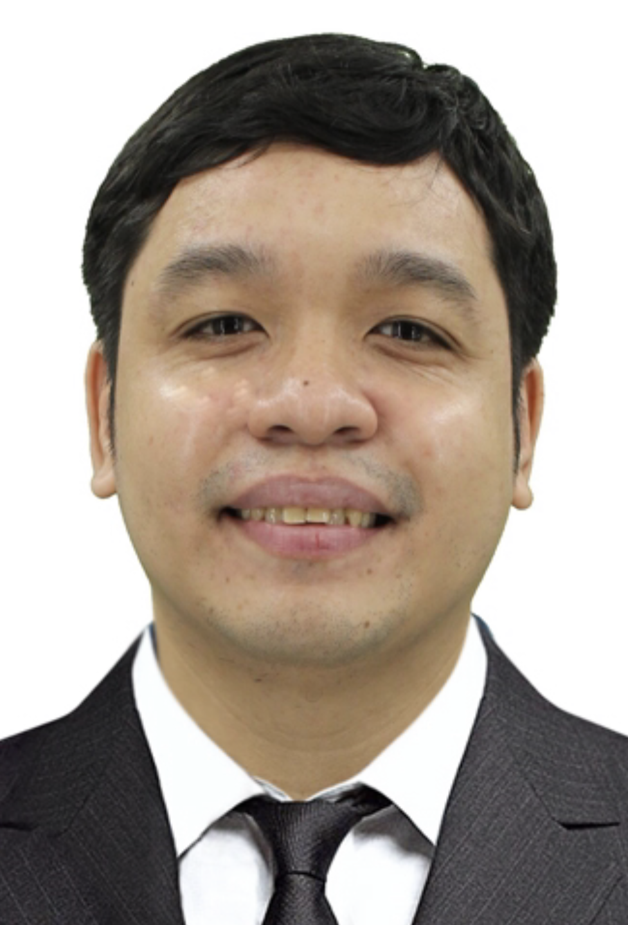
Jose Gregorio D. Villarba
Blk. 3 Lot 11 Ph. 1 Mabuhay Ave.
Andreaville, Salitran IV,
Dasmariñas, Cavite
Cellphone No. :09456701794
Email address: josegregoriovillarba@gmail.com

Employment History:
May 17, 2017 - February 01, 2023
Amkor Technology Philippines
119 N Science ave. , Laguna technopark, Binan Laguna
Equipment Specialist
*Repair, troubleshoot, setup, calibrate, diagnose, and convert handler and tester equipment. ( Srm348, Rasco1000, Multitest9917, Hontech9045, Delta, Existech and Pentamaster handler. ETS364, ETS200, and ETS88 tester).

April 13, 2016 - April 13, 2017
Cirtek Electronics Corporation
116 East Main Avenue, Phase V, SEZ Laguna Technopark Binan Laguna
Test Technician
*Repair, troubleshoot and set-up a handler, and tester. (wafer prober machine. LTXTS88, Credence, Tesec, Genesis, Eagle, Proscan, Scientific Test Instrument, Keithley tester, SRM handler, Sillner, MCT, Aetrium, Rasco, Tesec, and MT handler)
*Perform calibration of tester, conversion of handler and low yield verification.

January 05, 2015 – April 13, 2016
(EMS)Electronics Manufacturing Services
117A Technology Avenue, Laguna Technopark, Biñan Laguna
Equipment Maintenance Technician
*Assign at (FSCI) First Sumiden Circuit Incorporation where there I repair, trouble shoot, replace parts and maintenance of a machine. (OHT, AOI, CCD, Inkjet, Vacuum Sealer, Hot Press, VL, SSP, 35 and 10 toner, Autopasting, GHP, Oven and Symbol Printing Machines, Microscope)

August 22, 2012 November 22, 2012
Jtech. Philippines Inc.
Brgy. Javelera, Gateway Business Park, General Trias, Cavite
Equipment Technician
*Set-up machine, table, equipment, and outlet. (Oven, Heat Press, Welding Press, UV conveyor, Musashi Wire bond, and Cutting Press Machines)
*Perform maintenance and checklist on machines.
*Repair, Troubleshoot, and Program the system.

March 27, 2012 August 02, 2012
Integrated Microelectronics Incorporated (IMI)
North Science Avenue, Laguna Technopark, Biñan Laguna
Equipment Technician
*Assemble and install PC on a Machine including computer rack.( Jade Machine)
*Perform software installation and cloning of hard disk.
*Perform harnessing, trouble shooting and repair of PC.

Nov. 21, 2007 Nov. 21, 2011
Maxim Philippines Operating Corporation (Cavite)
Brgy. Javelera, Gateway Business Park, General Trias, Cavite
Equipment Technician
*Performing repair, troubleshoot, replace parts, and maintenance work on assigned equipment handler machine to ensure an efficient and effective high yielding machines at all times. (MT9510, MT9928, MT93XX, Aetrium 5050T, Aseco150D)
*Set-up the machine and perform conversion work based on production requirements.

June 21, 2006 December 21, 2006
On Semiconductor Philippines
Governors Drive, Brgy. Maduya St. Carmona, Cavite
Manufacturing Associate
*Perform testing of IC through a machine (MT93XX)
*Encoding data and loading program.
Personal Information:
Age : 38 yrs. old
Date of Birth : October 5, 1985
Place of Birth : Sta. Cruz, Manila
Citizenship : Filipino
Religion : Roman Catholic
Status : Single
Sex : Male
Height : 163 cm
Weight : 76 kg
Educational Attainment:
College : National College of Science and Technology
Amafel Building, Aguinaldo Highway, Dasmariñas, Cavite
(2013-2014) Bachelor of Science in Electronics and Communication Engineering (undergraduated)

College : Technological University of the Philippines at Cavite
CQT Avenue, Salawag, Dasmariñas, Cavite
(2002-2006) Computer Engineering Technology (graduated)

SSS no.: 33-8390149-6 Tin no.: 303-155-066
Pag-ibig no.: 1030-0081-2049 Philhealth no.: 08-050776055-8

