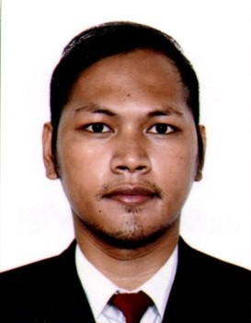
MICHAEL F. PIMENTEL

4940 Rue Richard St Hubert Quebec J3Y2M1
15148358013
michaelpimentel1522@yahoo.com

Highlights as a Welder Summary.

Certified welder with a completed 8+ years of experience with the different company's and different country in layout, fabrication, installation, and repair of industrial and commercial equipment, structural materials. Recognized for ability to complete welding projects at high-quality standards while following safety guidelines as well as minimizing costs and project time. Demonstrated leadership skills through training of junior welders which resulted in significant performance improvements.

Job Description:

- *Able to do welding with different kind of welding machines.
- *Shielded Metal Arc Welding or Manual Metal Arc Welding. (SMAW)
- *Metal Inert Gas Welding. (MIG)
- *Flux Cored Arc Welding. (FCAW)
- *Metal Core arc Welder
- *Stud Welding Machine
- Can understand and speak Japanese and English Language.
- Can work well with little supervision.
- Can operate Oxyacetylene gas cutting.
- I am knowledgeable in radial cutting machines.
- Can do repair jobs by using gouging machine.
- Can Wield heavy metals minimum of 12mm and up of thickness metals.
- Can read and interpret a blueprint drawing and welding symbols
- Prepare seams according to the procedure or specification.
- Oversee and verify the quality of the work
- Adjust welding, such as polarity, arc voltage, power; wire electrodes feed speed, and the product gas flow.
- Can do a operate the mobile crane or joists with the heavy loads like 1tons and up

Working experiences:
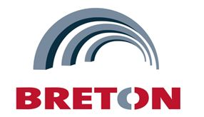
ACIER BRETON STEEL 2016 INC
500 Rue Sagard Saint Bruno de-Montarville J3V6C2
March 2, 2021 Up to Present.

Skills : Welder Fabricator
Working Hours : 10 hrs a day Night Shift

Duties & Responsibilities

Adept multitask able to complete a high volume of welding installation and repair projects with accuracy and
efficiency.
Flexible scheduling availability to include evenings some weekends and emergency situations as
necessary.
Machine and tools: MCAW machine, plasma, stud machine, Camber machine, gouging, grinder, hand
tools, magnet Drill, tourching conveyor and etc.
Exceptionally skilled and hardworking structural welder with an excellent work ethic and outstanding customer
service record.
Welding complete joint penetration with the back plate.
Superior skills in interpreting structural welding symbols excellent technical problem-solving and troubleshooting
abilities C WB MCAW WELDER in flat and horizontal AWS MCAW WELDER in flat and horizontal
Good in installation of galvanize angle bar in the H- beam high abilities in metal parts measuring cutting and fitting
Evaluated completed welding projects for flaws and defects. Ensured functionality and cleanliness of welding
materials and equipment working in details

SAITOH CO LTD.
516-2 Kinogo-cho, Kanonji-shi, Kagawa Japan
December 2015-December 2018

Skills : Welder Fabricator/Assembler
Working Hours : 8hrs a day

Duties & Responsibilities

- Assembly and welder, i know to read and apply the drawings and read the welding symbols
- Fabricated small items and welded with MIG machine
- Fabricated oil box, and welded using TIG, FCAW,MIG and SMAW machine,, this project is my common job on the company, i have my own place to fabricated this Oil box,, and need to be x-ray.
- Welded the pipe using TIG welding, sometimes welding aluminum and stainless
- Pioneer in this company as Filipino
- The Saitoh Company is mostly sub con of the big company that provides electricity in Japan. And the company mainly do the job like, electric Generator, electric House and the job must be clean at not sharp, because of the wires, not to damage.
- Using hydraulic jack and acetylene gas to straight again and reform the metal.
- Machine and tools: SMAW, MIG FCAW, TIG MACHINE, hand tools, magnetic Drill, plasma grinder .

AKH GENERAL CONTRACTOR
C6 Brgy. Wawa, Taguig City
June 2013-June 2015

Duties & Responsibilities

- Assemble and welder fabricated barges for the backhoe, trusses, sometimes structural beam, silo for cement, manholes cover, and repair some trucks and heavy machines. They send me in to the field for the repair projects.
- Machine and tools: SMAW welding machine, grinder, hand tools, magnetic drill, etc.
- Most of our projects are high way and road pavement, and government projects

EDUCATIONAL BACKGROUND

SECONDARY : LAS PINAS NATIONAL HIGH SCHOOL
June2008-April 2012

VOCATIONAL : TESDA MANPOWER LAS PINAS
SMAW/FCAW/TIG
June - October 2012 ( 3 Months )

(JITCO) Certified Complete of Technical intern Trainee in Japan.
I have completed 3 years as a technical intern trainee in Japan Industrial welder.

Here are some of my finished Job as a welder here in Canada,
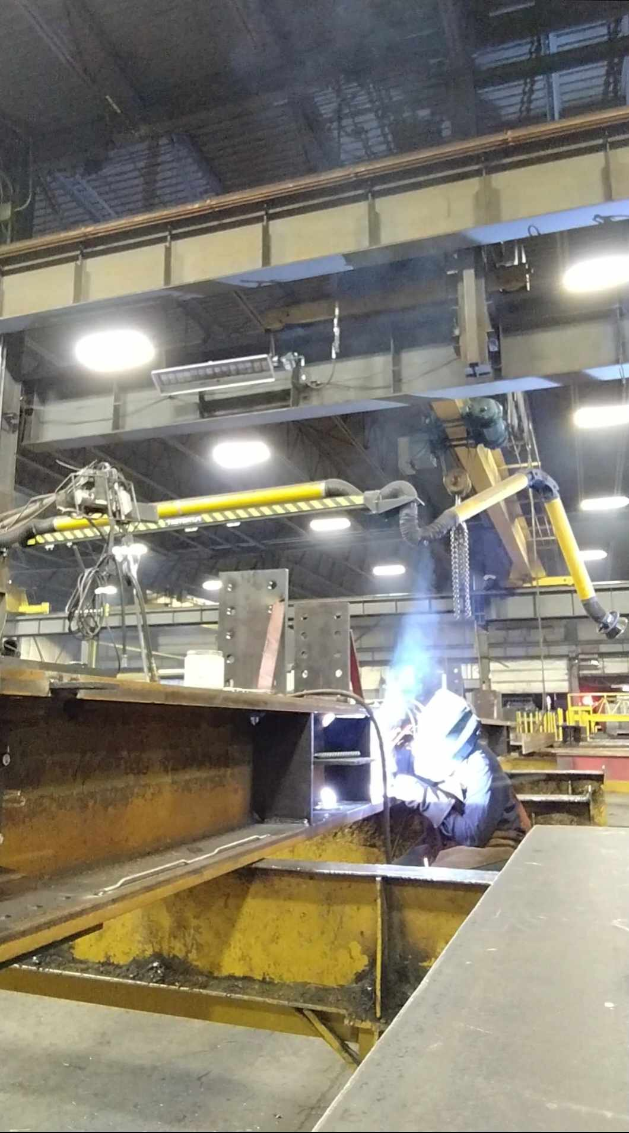 | 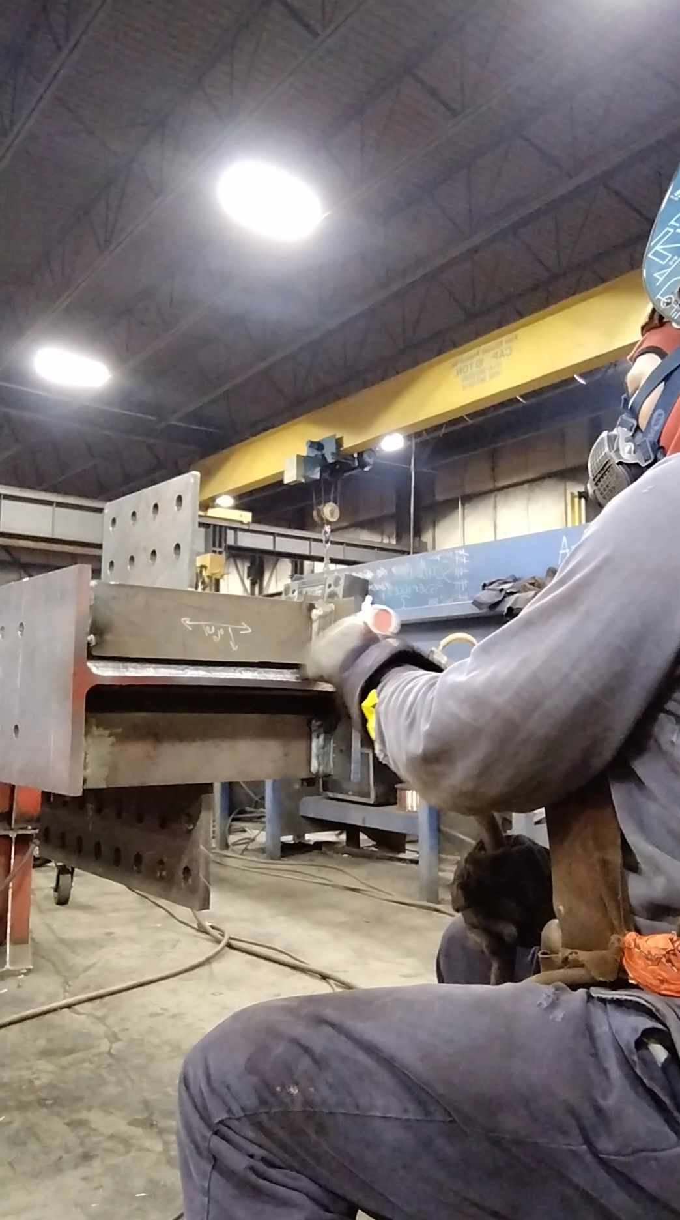 | 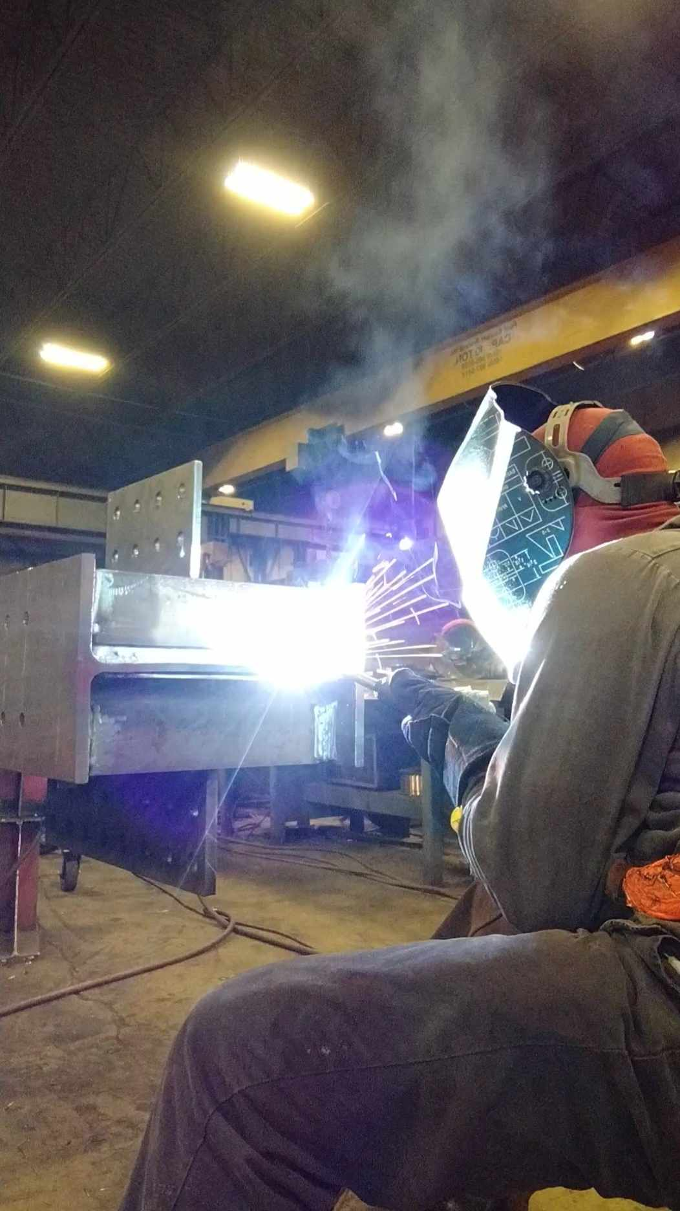 | 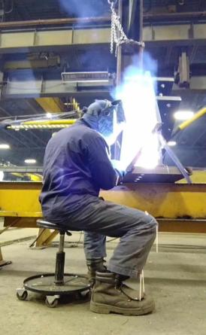
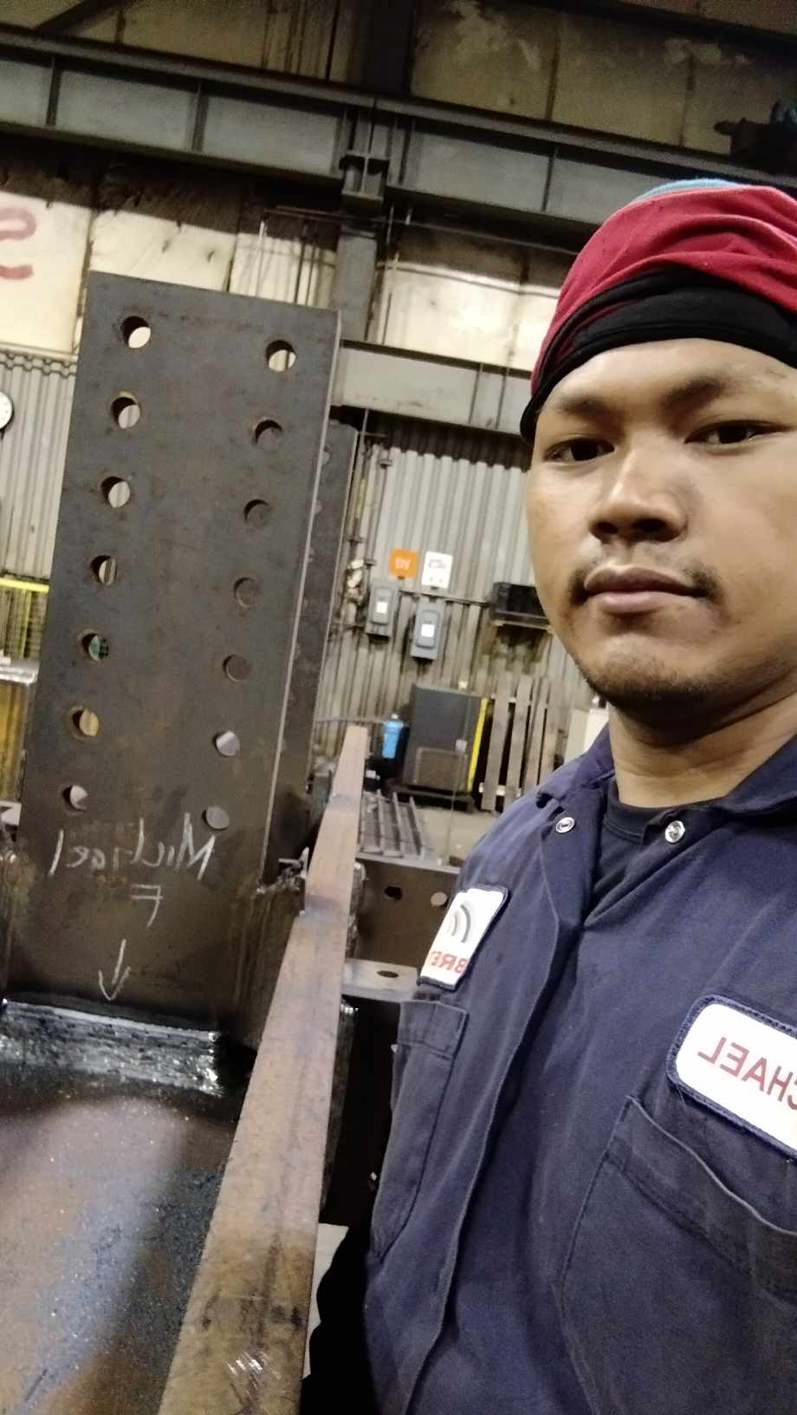 | 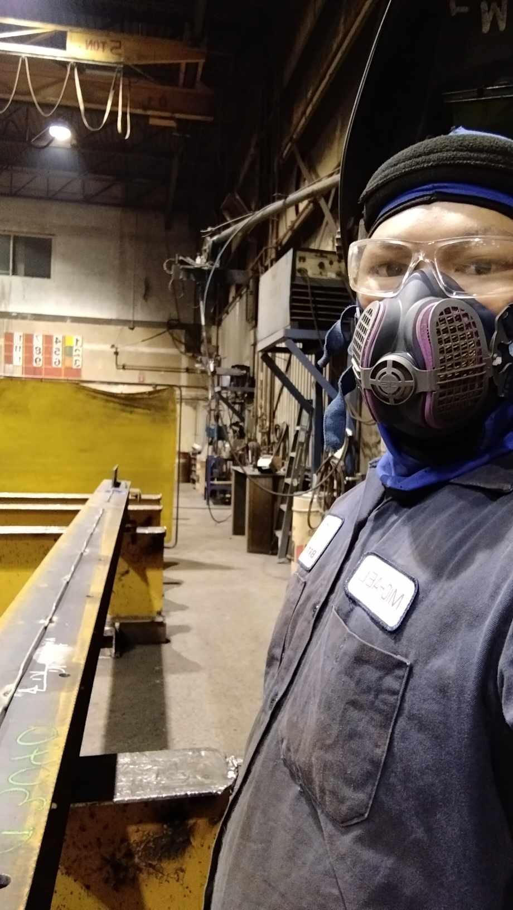 | 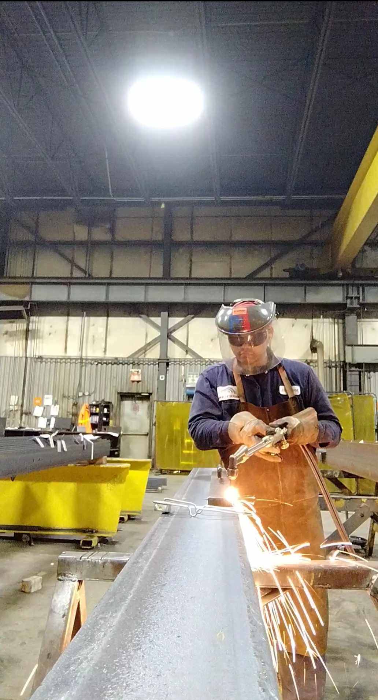 | 