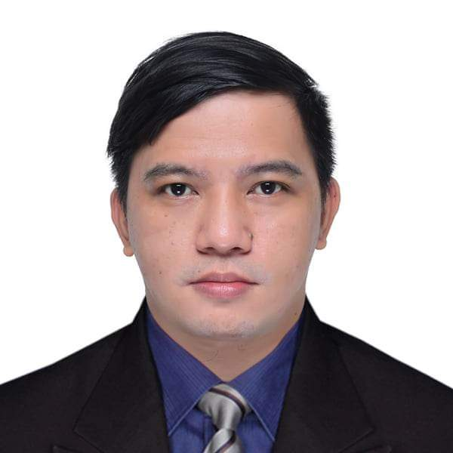
CURRICULUM VITAE

Jess Gutierrez Landicho
#100 Sitio Fatima, Betterliving Subdivision, Parañaque City
+63.906.0288.897/+63.919.366.1554
jess.landicho.1022@gmail.com

Position Overview
The job entails providing satisfactory service to the customers. The aim is to achieve target goals and increase productivity of the team. Other duties include planning, organizing, and directing associates to deliver excellent and high-standard work completion as what on the actual design, and support to the organization’s goals and production.

Optional Personal Information
Date of Birth: January 22, 1986
Place of Birth: Balanga Bataan
Citizenship: Filipino
Gender: Male
Height: 5’5” inch
Weight: 138.6 lbs.
Marital Status: Married
Spouse’s Name: Lucita Surbona Landicho
Contact No.: +63.995.6789.115

Educational Attainment

Short Training Course:

TESDA/RSTLP
#1445 Gabriel Street, Airport Road
Brgy. Baclaran, Parañaque City
Electrical and Installation Maintenance NCII
July 1, 2023 → November 4, 2023

TESDA/MDTAC
Bldg 9 TESDA Complex, East Service Road, South Luzon Expressway, Taguig City
DRIVING NCII
July 4, 2022 → August 4, 2022

FIRST LEAD
Ceylon Don Bosco Brgy Hall, Parañaque City
CALL CENTER TRAINING
December 2015 → February 2016

FAST-TECH
2nd Floor, W.T. Building. Guadalupe, Makati City
AUTOCAD
May 2008 → July 2008

College: Bataan Peninsula State University
San Jose, Balanga City, Bataan
Bachelor of Science in Civil Engineering
2003 → 2005

Secondary: Dra. Victoria B. Roman Memorial High School
Pantingan, Pilar, Bataan
1999 → 2003

Primary: Pantingan Elementary School
Pantingan, Pilar, Bataan
1993 → 1999

Employment History
Company: Grab
From: October 2018 up to Present

Essential Job Functions
- Giving a good service thru 2 wheels vehicles via using Grab Apps
- Provide the easiest way to buy their foods, pick-up and delivering their parcels, documents and etc.
- Giving a good vibe to all customer wants our services.

Company: Filsun Energy Builders
From: January 2016 up to September 2018

Essential Job Functions
- Admin Staff
- AutoCAD Operator
- Time Keeper
- Cable Pulling
- Install New Lighting Fixture/Switches, Outlet and Other Devices.
- Fabricate Necessary Cable Tray and Trunking etc.
- Install Cable Tray, Cable Ladder
- Install Isolator & Control Panel
- Terminate all Cable like XLPE/SWA/PVC/THHN/THWN/TW/MI or LSHF etc. in all Panel or Cabinet.
- Install all Grounding Air Terminal/Lighting Arrester and Bonding all around the building.
- Terminate Cable for Induction Motor.
- Continuity and Isolation Test Using Electrical Instrument.
- Pre-Commissioning and Test of Device and Panel.
- Energizing all Panels and Devices.
- Troubleshooting Electrical/Electronic Control Circuits.
- Tested and Repaired Electric Motors, VFD, Alarms and Control System.
- Interpreted Electrical/Mechanical Schematics/Blueprints and Diagrams.
- Repaired Electrical Equipment using Hand and Power Tools and Testing Diagnostic Equipment.
- Frequently Worked Overtime if Necessary Even Weekends and Holidays

Company: Crown Worldwide Group Inc.
From: 2007 up to November 2015
- 3 years as RMS Data-Encoder/Service Delivery Supervisor
- 3 years as RMS Database Officer
- 2 years & 11 months as RMS Customer Representative/Database Officer

Essential Job Functions
- Well versed in RSSQL Administration and Operations System
- Responsible to all customers inquiry, complaints, archiving procedures, operational procedures
- Oversee and execute all standard operating procedures and processes for down time and emergency as appropriate
- Supervise all RMS operations staff.
- Provide RMS training for all RMS Operations staff.
- Ensure that all operational procedures are enforced and properly followed.
- Assign work schedules for warehouse assistants to ensure that all items are pulled for delivery in a timely manner.
- Assign work schedules for warehouse assistants, to ensure that all received items are re-filed or put away in a timely manner.
- Assign work schedules for warehouse assistants, to ensure that destruction items are pulled and destroyed in a timely manner.
- Oversee dispatch and the preparation of driver routes to ensure scheduled pickups and deliveries are completed on time.
- Coordinate with the Account Relations Manager regarding special jobs for existing accounts, first uplift of new accounts, and routing problems.
- Coordinate with Operations Manager – Relocations regarding the use of their vehicles, labor and space.
- Coordinate with Manager – RMS regarding issues requiring further company support to ensure ability to complete jobs.
- Responsible for conducting regular location audits to ensure correct carton placement.
- Ensure quality of stored records is maintained.
- Ensure the warehouse is kept in a clean and organized state.
- Responsible in upgrading system of all scanners.
- Overtime if required

Core Competencies
- Determined
- Caring
- There
- Open-minded
- Sharing

Job Specific Competencies
- Quality
- Computer Skills
- Global Perspective
- Personal Organization

Aptitude, Experience and Qualifications
- Ability to encourage and motivate people with responsible attitude towards their work
- Excellent interpersonal skills
- Ability to plan and prioritize work properly
- Ability to prepare records and be calm under pressure
- Good decision-making, communication, and computer skills

Please feel free to contact:
Mr. Rudy Yadao – Rms Supervisor
822-1123 loc. 133/+63.917.636.6906

References.
Ms. Sunshine I. Japone – Asst. Manager Internal Audit
SM Super Market
+63.967.319.6941

Mr. Marcelo Apostol – RMS Warehouse Supervisor
Crown Worldwide Movers Inc – RMS Department
+63.947.401.8631

“I hereby certify that the above information is true and correct to the best of my knowledge and belief”

________________
Signature

