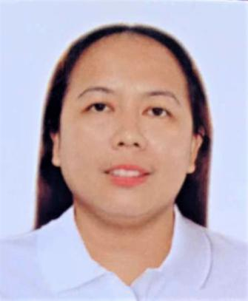
Genive Cabahug
Pinamungajan, Cebu
09490827660
genivecabahug@gmail.com

Objective
I'm a highly driven and goal-oriented person eager to put my skills as a midwife and nursing assistant to work, providing moms, newborns, and other patients with top-notch medical care.

Personal Information
Date of Birth : January 2, 1985
Place of Birth : Sitio Mohon, Aloguinsan, Cebu
Residence : Sitio Mohon, Tutay, Pinamungajan, Cebu
Citizenship : Filipino
Height : 5’0 ft
Weight: : 58 kg
Civil Status : Married

Education
Western Leyte College
Ormoc City
2002-2004 Midwifery

Qualification
License: Registerd Midwife

Experience
February 2022 - December 2023 Rural Health Midwife Placement Program
Department of Health Region 7
Aloguinsan, Cebu
Job Description
- Provide prenatal care and postnatal care.
- Monitor the health of pregnant women and assist in labor process
- Assessing care requirements and writing care plans
- Teach new and expecting mothers the basic care of babies
- Do immunization
- Do newborn screening
- Carrying out Screening test
October 2019 - February 2022 Midwife
Well Family Midwife Clinic
Pandacan, Pinamungajan, Cebu
Job Description
- Provide prenatal care and postnatal care.
- Monitor the health of pregnant women and assist in labor process
- Assessing care requirements and writing care plans
- Teach new and expecting mothers the basic care of babies
- Do immunization
- Do newborn screening
June 2012 - June 2019 Nursing Attendant/Midwife
PInamungajan District Hospital
Pandacan, Pinamungajan, Cebu
Job Description
- Assists ward nurses in attending rounds to patients
- Maintains cleanliness, orderliness and tidy beds
- Monitor’s the health of admitted patient
- Assists patients in performing basic tasks such as:
a. Giving bath to ambulatory patients
b. Serves drinking water and nourishment
c. Serving meals and helping feed patients
d. Dressing and/or changing of diaper and underpads if needed
e. Going to the toilets when necessary
- Escorts patient for any diagnostic procedures in and out of the hospita
- Assists patient to simple treatment like perineal care, cleansing enema and foley catheter.
- Takes and records patient's vital signs such as temperature, pulse and respiratory monitoring, fluid intake and output and blood pressure when delegated or as necessary.
- Monitors and ensures that all beds are complete with linen and pillow specially the roller beds during his shift and properly endorses them to the nursing attendant of the next shift.
February 2012 - December 2012 Rural Health Midwife Placement Program
Department of Health Region 7
Pinamungajan, Cebu
Job Description
- Provide prenatal care and postnatal care.
- Monitor the health of pregnant women and assist in labor process
- Assessing care requirements and writing care plans
- Teach new and expecting mothers the basic care of babies
- Do immunization
- Do newborn screening

Training and Seminar Attended
August 2-3 ,2019
BASIC LIFE SUPPORT AND AUTOMATED EXTERNAL DEFIBRILLATION OPERATION (2015 OSHA GUIDELINES)
August 1, 2019
BLOODBORNE PATHOGENS (2015 OSHA GUIDELINES)

Skills
- Ability to work and communicate effectively with people from different backgrounds
- Ability to follow instructions and procedures
- Ability to deal with emotionally charged situations
- Excellent team-working skills
- Strong observational skills

