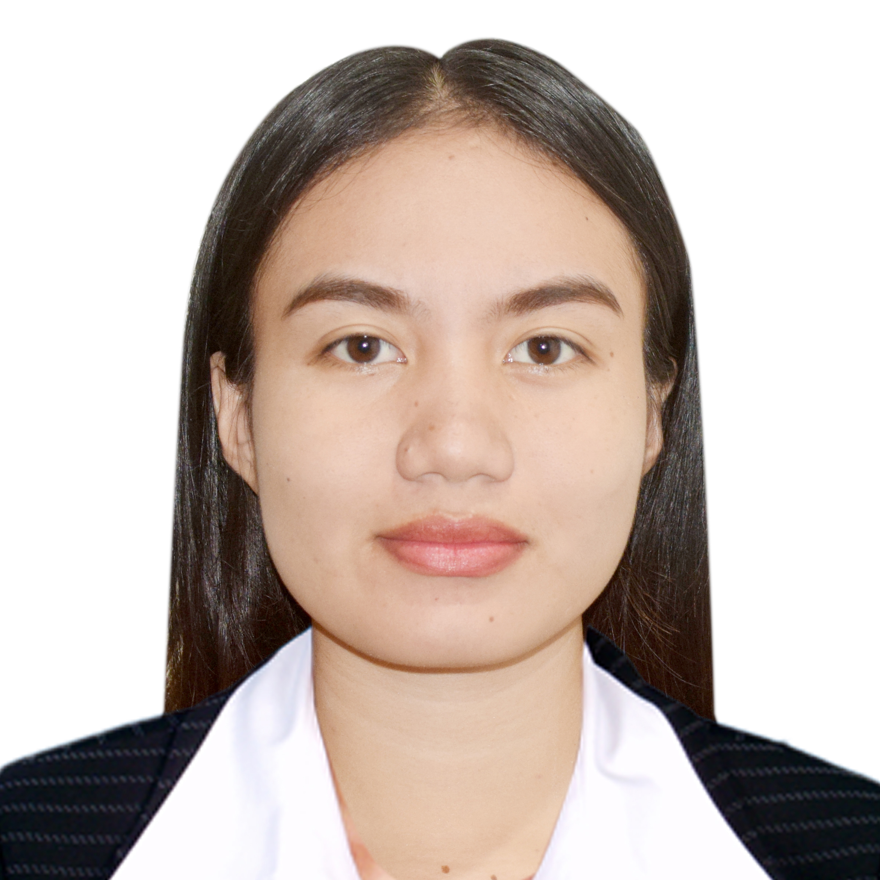
CHERRY BHEL G. PASCUA
Email Address: cherrybhel.pascua@gmail.com
Contact Number: 0967-601-5614
Address: Barumbong, Sto. Tomas, Isabela

CAREER OBJECTIVE:

- To gain more knowledge and develop my skills, that helps me more productive and become a better employee and become an asset of the company.

PERSONAL INFORMATION:

Birthdate: March 01, 2002
Birth Place: San Fermin Cauayan City, Isabela
Age: 21
Civil Status: Single
Citizenship: Filipino
Height: 5'3
Weight: 50kls
Religion: Roman Catholic
Father's Name: Donald V. Pascua
Mother's Name: Cherry Mar G. Pascua

EDUCATION:

TERTIARY: Diploma in Midwifery
(2022-2023)
Isabela State University - Ilagan Campus
SECONDARY: Isabela School of Arts and Trades
(2019-2020)
Calamagui 2nd Ilagan City, Isabela
PRIMARY: Barumbong Elementary School
(2013-2014)
Barumbong, Sto.Tomas, Isabela

SKILLS AND QUALIFICATIONS:
- Hardworking
- Patient
- Can Work Under Pressure
- Easy To Learn
- Goal Oriented
- Honest
- Good in using MS-Office (ms-Word, ms-Excel, ms-Powerpoint)
- Competent
- Creative and Resourceful

WORK EXPERIENCE:
-SALES ASSOCIATE
Pamela Aileen Enterprises
Cartimar Pasay
CHARACTER REFERENCES:
Mr.Roger Garcia
Manager
Millenium Foodbite Corp.
Santiago City

I hereby certify that the facts contained in this resume are true and correct to the best of my knowledge and belie

Cherry Bhel G. Pascua
Applicant

