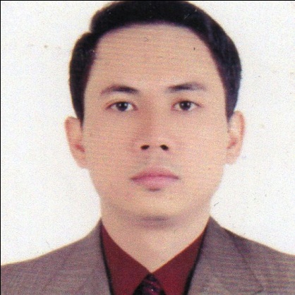
RUBEN M. ALCARPIO Jr.
Sta. Clara Batangas City
Contact No. +639073239275
Passport No. P2853750C

Position Desire:PLUMBER

Career Objectives

Employment in a position where I could enhance my career and development skill to my work for a company encourages its personel to use knowledge and past experiences as well as future training to secure a position with room for growth.

Work Experience
- Plumber
Phesco Incorporated
Batangas State University
November 3, 2022- July 31, 2023

- Pipe Fitter/ Structural Fitter / Fabricator
Jop-son Enterprises
ATI Batangas
February 6, 2021 - August 29, 2022

- Plumber
Phesco Incorporated
Batangas State University
December 5, 2020 - February 11, 2021

- Scissor Lift Operator
AG&P
Brgy. Simlong Batangas City
JG Summit/OSBL Project
January 16, 2019 – December 21, 2019

- Pipe Fitter/Plumber
ATI Batangas
NW Steel
August 15, 2017 – August 20, 2018

- Pipe Fitter
AG&P
PPA Batangas
Tesoro Project
March 21, 2017 – September 11, 2017

- Structural Fitter
AG&P
PPA Batangas
Ichthys Project
May 13, 2014 – April 21, 2016

- Pipe Fitter
AG&P
San Roque Bauan, Batangas
Bechtel/Gladstone LNG Module Yard Project
November 13, 2012 – December 16, 2013

- Pipe Fitter
AG&P
San Roque Bauan, Batangas
Foster Wheeler-BP-Coker
July – September 24, 2010

- Pipe Fitter
Keppel Batangas
Barangay San Miguel, Bauan Batangas
June 14, 2003 – June 22, 2007

Personal Data
Date of Birth : January 26, 1982
Civil Status : Married
Citizenship : Filipino
Sex : Male
Religion : Roman Catholic
Height : 5’5
Weight : 147 lbs.
Language Spoken : Filipino/English

Educational Background

Vocational : ST JAMES VOCATIONAL SCHOOL AND TRAINING CENTER FOR
ADVANCEMENT, INC.
Kumintang Ilaya Batangas City
December 15, 2009 – January 22, 2010
Course: Pipe Fitting

Secondary : Batangas National High School
Rizal Avenue, Batangas City
1996 – 2000

Primary : Sta. Clara Elementary School
Sta. Clara Batangas City
1990 – 1996

Character References

Derick B. Arago
Barangay Chairman
Sta. Clara Batangas City

Arlene A. Lacsamana
Barangay Councilor
Sta. Clara Batangas City

I hereby certify that the above information is true and correct to the best of my knowledge and belief.

Ruben M. Alcarpio Jr.
Applicant

