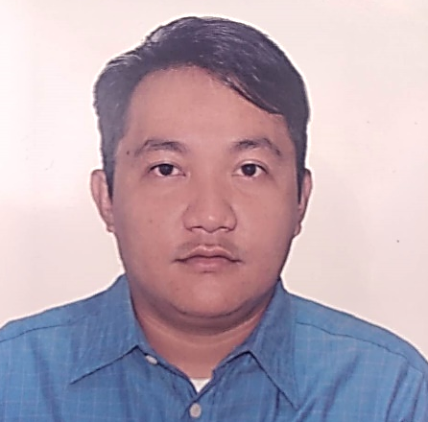
DARYLL KEN C. CAMPO
Lawaan III Talisay city Cebu
Dariozkie34@gmail.com
09566036569

PERSONAL OBJECTIVES

● To apply any position that fits my qualification
● To motivate and explore by sharing ideas to one another

WORK EXPERIENCE

● Prince Warehouse Club Inc.
Sales Clerk
November 2014 – June 2015

● Prince Warehouse Club Inc.
Stockman
July 2015 - January 2016

● Cebu Atlantic Hardware Inc.
Checker
January 2016 - December 2016

● Mi Department Store (Emall)
StockMan
August 2018 - December 2018

● Kaakbay sa Kinabukasan
Promodiser (Tamsons)
May 2019 - February 2023

EDUCATIONAL BACKGROUND

- Primary
Tabunoc Central School
1997 – 2003
- Secondary
Lawaan III National
Night High School
2006 - 2012

PERSONAL INFORMATION

Date of Birth: March 13, 1991
Place of Birth: Cebu City
Age : 32
Civil Status : Single
Religion : Roman Catholic
Height : 5'7
Weight : 79Kgs
Language : Filipino/English

CHARACTER REFERENCE

Teacher III
Deped Talisay City
Lawaan III Elementary School

Lawaan III, Talisay City, Cebu
09310198867

