PROFILE

I graduated with a Bachelor’s degree in Secondary Education major in Music, Arts, Physical Education and Health (MAPEH), a Licensed Professional Teacher and currently taking up Master of Arts Education Major in Physical education. I am equipped, hardworking, and a responsible individual to do and manage the task very well.

EDUCATIONAL BACKGROUND

TERTIARY:
Bachelor’s Degree in Secondary Education major in MAPEH
Pambayang Kolehiyo ng Mauban
Mauban, Quezon
2015-2019

SECONDARY:
Liwayway National High School
Brgy. Liwayway Mauban, Quezon
2010-2014

PRIMARY:
Liwayway Elementary School
Brgy. Liwayway Mauban, Quezon
2004-2010

ORGANIZATIONAL AFFILIATION

Member of League of Music, Physical Education, Arts and Health (Le'MuPEAH)

SKILLS

- Computer literate
- Hardworking
- Determined
- Easy to adapt different working environment.
- Responsible

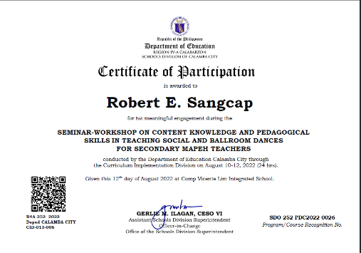


ROBERT E. SANGCAP
Blk 17 Lot 20 Bria Homes Bañadero
Brgy. Bañadero Calamba City Laguna
Contact: 09072861745
resangcap@gmail.com

PERSONAL DATA

NICKNAME : Robert
GENDER : Male
AGE : 25 years old
HEIGHT : 5’9
WEIGHT : 85 kg
DATE OF BIRTH : January 02, 1998
PLACE OF BIRTH : Mauban, Quezon
NATIONALITY : Filipino
CIVIL STATUS : Single
FATHER : Emiliano M. Sangcap
MOTHER : Marilou P. Esmeria
RELIGION : Roman Catholic
LANGUAGES SPOKEN : Filipino, English

CAREER OBJECTIVE

To gain an additional productive skill for professional growth and work in an environment that requires a responsible individual and in return I will guarantee that I will be the asset of the company.

WORK EXPERIENCE

JAN. 05, 2021 – TEACHER I
PRESENT Looc Integrated School
Brgy. Looc Calamba City, Laguna

SEMINARS

APRIL 28, 2023 RECONSTITUTING AND STRENGTHENING OF GAD FOCAL POINT SYSTEM

MARCH 09, 2023 TRAINING-WORKSHOP ON THE QUALITY ASSURANCE OF LOCALIZED, INCLUSIVE AND DEVELOPMENTALLY APPROPRIATE DEVELOPED LEARNING RESOURCES

AUGUST 10-12, 2022 SEMINAR-WORKSHOP ON CONTENT KNOWLEDGE AND PEDAGOGICAL SKILLS IN TEACHING SOCIAL AND BALLROOM DANCES FOR SECONDARY MAPEH TEACHERS

DECEMBER 03, 2021 ENHANCING CONTENT KNOWLEDGE AND PEDAGOGICAL SKILLS OF MAPEH TEACHERS IN TEACHING MUSIC AND ARTS: A WEBINAR-WORKSHOP

CHARACTER REFERENCES

RAZHEL D. TRAVINIO
Teacher II
Looc Integrated School

AARON D. DELOS SANTOS
Special Science Teacher I
Looc Integrated School

JULIET MONTANO
Head Teacher III
Looc Integrated School

I hereby certify that the above information is true and correct to the best of my knowledge and belief.

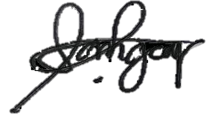

ROBERT E. SANGCAP
Applicant Signature

