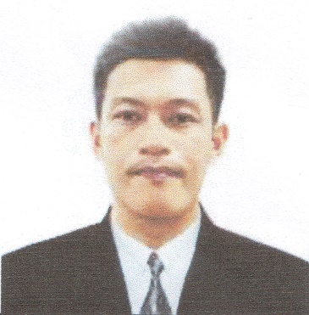
ERWIN L. TABUDLONG
Brgy. Ipil 1 Blk. 52 Lot 6 Silang, Cavite
tabudlongsendoh@gmail.com
09319038048

Work Experience:

Shinkozan Corp. is a sheet metal fabrication company servicing almost all industrial in need of thin sheet metal fabrications and assemblies.

Company name: Workers Janitorial Manpower Service at Shinkozan Corp.
Mt. View 2 Hong Chang Compound Bo. Bangcal Carmona, Cavite
Position: GMAW, SMAW, GTAW WELDER
Inclusive date: April 10, 2017 – Present

Task and responsibilities:

- Set-up and operate MIG welding robot.
- Perform machine basic trouble shooting and or prescribed maintenance as required.
- Perform daily preventive maintenance as required.
- Analyze and interpret drawing.
- Perform all dimensional inspections.
- Prepares Kaizen improvement monthly.
- Communicate job exceptions and performance requirements.
- Initiate, coordinate and enforce production, safety and quality system policies and procedures.
- Implement 5s on working area.
_
Career Related Skills:
- Grinding/Buffing.
- Spot welding.
_
Equipment / Machines use and handled
- OTC Digital dyna-auto (XD350S)
- OTC CPV 400
- Daihen AYP-300P (S-4)
- OTC FD-B4L
_
Educational Background:

Vocational : Guardians Technical School
Electrical Installation and Maintenance (NC-II)
Blk. 2 Lot 17-19 Brgy. San Gabriel GMA, Cavite
July 31-August 20, 2018
Shielded Metal ARC Welding (NC-II)

Secondary : Dasmariñas National High School
Silang, Cavite
1997-2001

Primary : Bagong Buhay Elementary School
Bulihan Silang, Cavite
1991-1997
_
Personal Information:

Date of Birth : August 17, 1985
Age : 38 Years old
Place of Birth : General Mariano Alvarez, Cavite
Name of Father : Rogelio Tabudlong
Name of Mother : Lilia Lacanaria
Religion : Roman Catholic
Sex : Male
Civil Status : Single
Language Spoken : English, Tagalog

Person to be contacted in case of emergency:
Name : Glenda Gutierrez
Contact no. : 09516651825
_
Character References:

Noel Lacasa
Engineer

Mark Daniel Tarroza
Supervisor
(046) 481-4088 local 75

_______________
Erwin L. Tabudlong

