MARK JOSEPH PASCUAL | 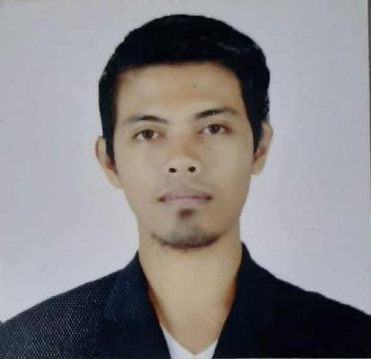

pascualmarkjoseph08@gmail.com | www.linkedin.com/in/markpascual08 | Al Janubiyah, Al Khobar

+966576246034

OBJECTIVES

To secure a challenging role in a professional environment, utilizing my skills, strong work ethic, and willingness to take on new responsibilities to contribute to the success of the company.

Seeking an opportunity in the Facility Management industry, where I can leverage my technical skills, adaptability, and passion for innovation to contribute to projects, learn from experienced professionals, and develop a successful career.

CAREER HIGHLIGHTS

Accomplished in making good relationship with the clients to cooperatively achieve company goals while providing educational and strategical techniques.

Meticulously prepared Monthly reports to the clients, providing critical insights into Key Performance Indicators and enabling data-driven decisions.

Expertise in Integrated Pest Management with more than 9 years of experience.

PROFESSIONAL SUMMARY

Company | : AL YAMAMA COMPANY
Address | : Dammam, KSA
Date | : December 2021 up to Present
Position | : SUPERVISOR at SAUDI ARAMCO KACWC ITHRA.
Job Description |  | - Provide supervision, assess and anticipate intervention base on specialized knowledge and technical skills.  - Ensuring the development of effective KPIs to measure the performance of the department.  - Respond to the client inquiries and concerns and providing best solutions to the client.  - Perform assessment, maintain accurate records of daily, weekly and monthly activities.  - Execute plans and procedures through Standard Operating Procedures.  - Maintain Supplies and equipment necessary to facilitate efficiency of assigned task.

Company | : KHIDMAH SAUDI LCC
Address | : Al Khobar, KSA
Date | : August 2017 to December 2021
Position | : PEST CONTROL SUPERVISOR at SAUDI ARAMCO KACWC ITHRA.
Job Description |  | - Execute plans and procedures through Standard Operating Procedures.  - Determine the type of treatment required to control pests.  - Inspect sign of infestation in internal and external bldg. facilities.  - Responsible for daily, weekly and monthly pest control works and securing valid Saudi Aramco work permits for Pest control activities.

EDUCATIONAL BACKGROUND

College | : LAGUNA STATE POLYTECHNIC UNIVERSITY
Address | : San Pablo City, Laguna Philippines
Date | : 2006 - 2008
Course | : ASSOCIATE IN TECHNOLOGY MAJOR IN ELECTRONICS (2 Years Course)

High School | : DIZON MEMORIAL NHS
Address | : San Pablo City Laguna, Philippines
Date | : 2002 - 2006

Primary | : DEL REMEDIO ELEMENTARY SCHOOL
Address | : Brgy. Del Remedio San Pablo City
Date | : 1996 - 2002

TRAINING / SEMINARS AND CERTIFICATES
Course | : SA-WORK PERMIT RECEIVER
Organization | : Saudi Aramco Training Center
Address | : Industrial Training Center Ras-Tanura KSA
Cert ID. | : 292746

Course | : Work Permit Receiver Pre-Requisite
Organization | : Human Assets Training Institute
Address | : Al Khobar KSA
Cert ID. | 01305-8755 (12/02/2022 – 11/20/2024)

Course | : Powered Access License
Organization | : IPAF (INTERNATIONAL POWERED ACCESS FEDERATION)
OP/ no. | : 1845683

Course | : Heart Saver and First Aid
Organization | : Saudi Heart Association National CPR Committee
Cert ID. | : 00303210986867

Course | : Integrated Pest Management Seminar
Organization | : Entom Pest control
Address | : Entom bldg. Almanza 2, Las Pinas City

Course | : Pesticide Safety; First Aid; & CPR; Fire Safety
Organization | : Safety Seminar
Address | : North Avenue Quezon City.

Physical Capabilities:
- Able to speak English.
- Able to Drive Manual and Automatic Vehicle
- Able to work in a confined space location.
- Able to Operate Man Lift Machines.
- Trouble shooting.
- Ability to work under pressure.
- Physically fit and flexible.
- Inventory & Stocks Handling.
- Attention to details.

Computer Skills:
- MS Office
- MS Excel (Spreadsheet)
- MS PowerPoint (slide show/presentation).
- Email

PERSONAL INFORMATION

Date of Birth | : October 08, 1989
Place of Birth | : San Pablo City, Laguna Philippines
Age | : 34 y/o
Civil Status | : Married
Height | : 5’ 6”
Weight | : 78 kg
Driver’s License | : KSA Valid Driver’s License

I hereby certify that the above information are true and correct.



MARK PASCUAL
Applicant

