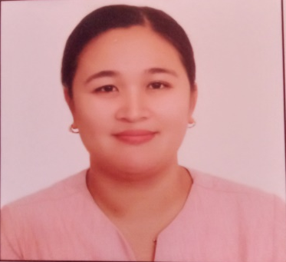
CURRICULUM VITAE

SHERYL P. TINIO
462, Camias, San Miguel Bulacan
Contact Number: 0977-211-4585

- Education Background:

Post Education : Master of Arts in Educational Management
Dr. Gloria D. Lacson Colleges Inc.
San, Leonardo, Gapan Nueva Ecija
March, 2018-2020

Tertiary : Bachelor of Elementary Education
St. Paul University Philippines
Tuguegarao City, Cagayan
March, 2003-2007
Secondary : Gamu Rural School
Linglingay, Gamu Isabela
March, 1999- 2003
Elementary : San Bonifacio Elementary School
San Bonifacio Burgos Isabela
March, 1993-1999

- Work Experiences:

Teacher III, San Miguel North Central School, 2019 - present
Teacher I, San Miguel North Central, 2015 - 2019
Volunteer Teacher,King Kabayo Elementary School, 2014 - 2015
Elementary Teacher, St. Paul University at San Miguel, 2008-2014

- Personal Information:

Name of Spouse : Reynaldie S. Tinio
Children : Sheyna Reyn P. Tinio
Shan Rey P. Tinio

Name of Father : Leopoldo G. Palaguitto
Name of Mother : Visitacion M. Papa
Date of Birth : September 10, 1986
Place of Birth : Burgos, Isabela
Sex : Female
Age : 36
Civil Status : Married
Religion : Roman Catholic
Height : 5 feet 6 inches
Weight : 75 kilograms

