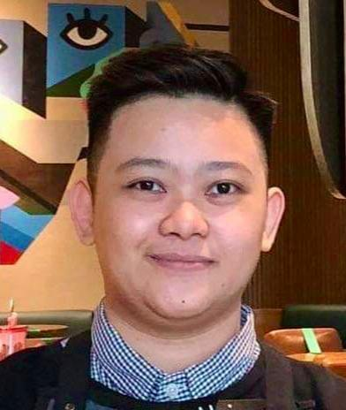
Ma. Charlene F. Baltazar
Unit 1409 Flair Towers North Reliance St.
Brgy. Highway Hills, Mandaluyong City 1550
+1 (778) 806-2677
lfbaltazar8@yahoo.com

I’m able to work under pressure, passionate, a leader and a team player, champion in customer service, and mastered a Can-Do attitude.

Skills
- MS Office Knowledgable
- Proficient in Numbers
- Excellent Communication Skills
- Experienced Trainer
- Coffee Master

Experience

October 2018 - PRESENT

Starbucks Philippines, Makati City - Shift Supervisor
- District Coffee Master
- Barista Trainer
- Handled stocks and ordering
- Marketing specialist

May 2017 - August 2017

Tendon Kohaku, Taguig City - Kitchen Specialist
- Assigned in fryer area
- Handled inventory
- Trained in cold station, dispatch, and hot station

Education

June 2013 - April 2017

Emilio Aguinaldo College, Manila - Bachelor of Science in Hotel and Restaurant Management

Central Student Council President
- College President (BSHRM)
- Board Member (Student Representative)

Awards
- Partner of the Year 2020 & 2023
- Area District Coffee Master 2023
- Partner of the Quarter 2019, 2020 & 2021
- Barista Trainer 2019
- MAFBEX Silver Medalist 2016
- National Food Showdown Diploma Award 2016

