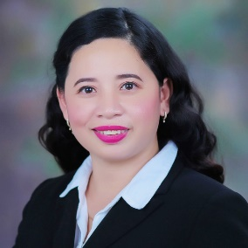

MIMI MARTINEZ MONDARES
Address: #125 Agdao San Carlos City, Pangasinan
Contact Number: +639126639074 /+639062441077

EDUCATION:

June 2011 - April 2014 Pangasinan State University – San Carlos Campus
San Carlos City, Pangasinan
Course: Bachelor Secondary Education
Major in Social Studies

June 2000 – April 2002 STI - SAN CARLOS
Aurora Bldg. Taloy St. San Carlos City Pangasinan
Course: Diploma In Information Technology

June 1994 - April 1998 Saint Charles Academy
San Carlos City, Pangasinan

June 1989 - March 1994 Magtaking Elementary School
Magtaking San Carlos City, Pangasinan
WORK EXPERIENCE:

January 2023- May 2023 Bookkeeper
KnK Moreno Corporation
Mamarlao ,San Carlos City Pangasinan

L.E.A.D Academy of Urbiztondo
Urbiztondo, Pangasinan
June 2018 – April 2019 4th grade adviser
June 2019 - April 2020 6th grade adviser
July 2020- April 2021 5th grade adviser & Assistant Registrar

June 2015 – April 2018 Secondary Teacher in Araling Panlipunan
Urbiztondo Private High School
Urbiztondo,Pangasinan

November 2013 – February 2014 Off-Campus Teaching
Buenlag National High School
Buenlag Calasiao, Pangasinan
TRAININGS AND SEMINARS ATTENDED

March 2, 2019 WHOLE CHILD EDUCATION AND 21ST CENTURY ASSESSMENT STRATEGIES
Dominican School of Dagupan City, Pangasinan

November 23-24,2018 PHILIPPINE PROFESSIONAL STANDARD FOR TEACHER (PPST) AND RESULTS – BASED PERFORMANCE MANAGEMENT SYSTEM
( RPMS)
Urbiztondo Sports Complex, Urbiztondo Pangasinan

April 15-30, 2017 Training of Microsoft Word,Microsoft Excel
and Microsoft Powerpoint
Urbiztondo Private High School
Urbiztondo, Pangasinan

CHARACTER REFERENCES

EVANGELINE R. DE GUZMAN,Ed.D
Elementary School Principal
L.E.A.D. Academy of Urbiztondo School
Urbiztondo ,Pangasinan
+639097150840

ALMA S. KOEN, Ed.D
School Directress
L.E.A.D. Academy of Urbiztondo
Urbiztondo, Pangasinan
+639307149545

I hereby certify that the above information provided herein is true and correct to the best of my knowledge and belief.

MIMI M.MONDARES
Applicant

