ARTHUR ESTANISLAO VIRAY
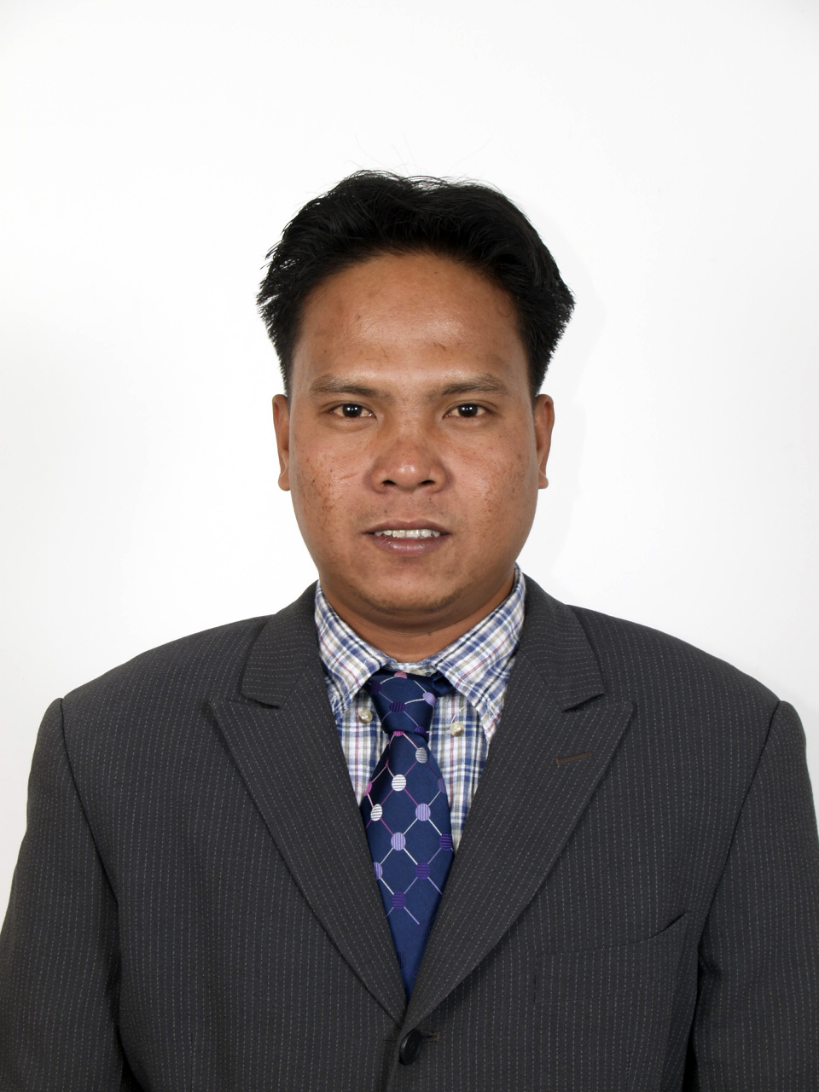
AL-DAWWA MEDICAL SERVICES P.O BOX 4326 ALKHOBAR K.S.A
CONTACT NO. +966561312641
EMAIL ADDRESS: arthurviray63@yahoo.com

POSITION DESIRED: Machine Operator/Truck Driver
OBJECTIVE

-To ensure that the job order or ticket enevelope is carefully analyzed, planned, executed and controlled apec, the push button control in good running condition. The material are always sufficient for the job on hand and to oversee the work and job performance of this Blowing Machine Corporation.
-To share with the company’s Vision on improving the lives of people for the country’s progress.
-To be able to meet and work with descent and broad minded people that will push my capabilities to a higher level.
-To showcase my skill and obtain more knowledge by working with new breed of people.
-To take part on the challenge of developing myself within your company that offers extensive training on technical skills leading to professional Development.
PERSONAL INFORMATION
Date of Birth : August 17, 1978
Place of Birth : Ibayo Napindan Purok #6 –C Taguig city
Age : 36 years old
Height : 5 feet 3 inch
Weight : 72kgs
Father Name : Antonio Viray
Occupation : Farmer
Mother Name : Elizabeth Viray
Occupation : Sewer
Religion : Christian
Civil Staus : Married
Citizenship : Filipino
Language /Dialect : Filipino, English and Arabic
EDUCATIONAL BACKGROUND
Primary : Napindan Elementary School Taguig City
: 1991-1992
Secondary : Moncada Catholic School Moncada Tarlac
: 1996-1997
SKILLS

Forklift Operator, Driving heavy truck, Machine Operator and Sales Marketing

WORK EXPERIENCE

UNIVERSAL ROBINA CORPORATION
ROSARIO PASIG CITY
From 1998-1999
Position : Factory worker/Packaging

ROWELL PLASTIC CORPORATION
Libis Quezon City
From 2000-2003
Position : Blowing Machine Operator
: Injection Blowing Machine Operator (IBMO)
: Forklift Operator

ROWELL LITHOGRAPHY CORPORATION
Bagumbayan Quezon City
From 2003-2005
Position : Filling Filter Printing Press
: Forklift Operator

CHEMPHIL L.M.G CHEMICAL CORPORATION
Taguig City
From 2005-2007
Position : Filter Press Operator

AL-DAWAA MEDICAL SERVICE CO. LTD
Al-khobar Kingdom of Saudi Arabia
From 2008- present
Position : Sales Merchandiser
: Truck Driver
CHARATER REFFERENCE

-AL-DAWWA MEDICAL SERVICE Co. LTD
P.O Box 4326 Al-Khobar 31952 Kingdom of Saudi Arabia
Tel: # +9663 8677-776, 8677-8677-676, 8674-151
Fax # 8670-201

I cetify that the above statement and information are true and Correct to thebest of my knowledge and Beliefs

Arthur Estanislao Viray

