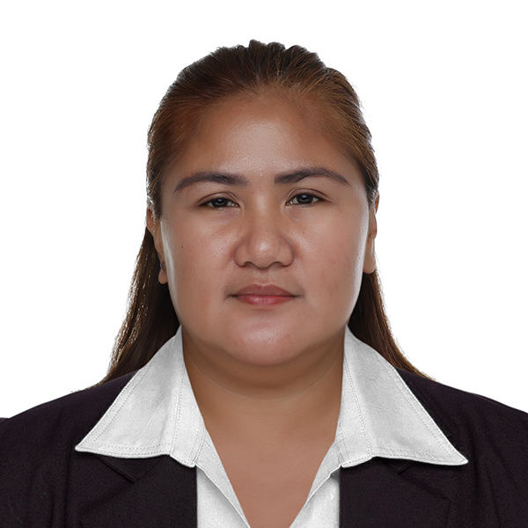
Curriculum Vitae
PERSONAL
Name Sheryl Tuzon Alejo
Address Road 5, 822-I Camp Aguinaldo, Cubao, Quezon City, 1110
Phone number +639171503807
Email salejo86@yahoo.com
Date of Birth 02 February 1982
Place of Birth Matalam North Cotabato
Passport Nr P8503102A
Marital Status Married
Spouse name Alfredo Ambay Alejo Jr
Spouse job AFP (ARMMED FORCES of the PHILIPPINES
Height 5;3 (160.02 cm)
Weight 76 kg (167.55 pounds)

RESUME OBJECTIVE

Hard working personal support worker with a passion for assisting people in need. Demonstrates dedication to a high – quality job performance when assisting individuals by displaying patience and empathy. Looking for an opportunity to use my skills and gain experience helping people in challenging situation.

WORK EXPERIENCE

September 2020 up to Present: I’m the one taking good care of my parents because they are both senior, specially with my father when he got sick because of COVID-19. He suffered a lot because of severe coughing. That time its so difficult for the family because there is no vacant room in the hospital and they are not accepting anymore so me and my family decided that I will take care of my father. We contacted Dr. Young about my father’s situation then he gives his telephone order if what we need to do. That time my father’s situation is very bad because he got severe pneumonia. I’m doing back tapping to my father to profuse airway secretion. Thanks God he overcome that COVID -19 and till now his doing well.
In mid- year I got pregnant and I deliver my baby boy name Nathanel (Ethan), I personally take good care of my baby and now his 15 moths old. At the same time, I’m taking good care of my business too name SHERYL FRUITS TRADING, I have 2 helpers for my business because its 24 hours open Monday to Sunday.
Accident happens to my mother during Church time in our Province and She got a serious injury last May 2023, that time she’s suffering of severe pain. After consulting a doctor, she undergo operation Right Femur fracture (open and close reduction), from that moment I’m the one taking good care my mother, after operation her doctor advise her to do bedrest and few exercise only. I’m the one doing bed bath, changing diaper as needed and doing position every hour and as needed. Weeks after we started walker with the advice of her Physiotherapist, I’m the one helping her doing exercise and that time we need to have extra careful because its limited only what she need to do and thanks God after months, taking good care of my mom she’s doing well now, she can walk slowly with her walker, she can take shower alone and she can take good care her own flowers at home.
Being caregiver is amazing job for me because we need to have a lot of patience so that we can give our love and care well to our patient and for me being optimistic towards our patient is very important.

Feb 2015-Sep 2020 CAREGIVER
Agam Nursing Agency, Israel

I was working as a caregiver, taking good care my patient with Alzheimer
Disease and cancer. (Finished Contract)

My daily routine to my patient is first, taking blood pressure, checking her RBS (Random blood Sugar) giving some heads up to my patient because I want her to feel that I really do care for her, after that I will prepare her breakfast and morning medicines. Around 7 in morning I will accompany her to take a shower and changing her clothes, after awhile we will do our routine exercise after that I will prepare her snacks then I will give time on her own and that time she loves to read books and sometimes she love to watch television, and while she’s busy I’m preparing our lunch, then after our lunch she love to take a nap, and during she’s sleeping I’m cleaning and doing washing her own clothes and when she woke up she will drink her coffee ,after that we will go to the Park, will stay there, were just talking sometimes walking too it depends to the weather outside. During night time after her dinner, after giving her medicines she loves to watch tv and after giving her medicines at bed time she will go to sleep. Sometimes in the middle of the night she will call me because she thinks that morning already. Taking good care of patient with Alzheimer’s you should know how to balance your time, should know how to handle patient Alzheimer’s if they are aggressive, and most specially we should know how to respect patient with love and care.

Jun 2009-Jul 2014 STAFF NURSE
Ministry of Health’, Kingdom of Saudi Arabia

I was working as a Staff nurse in Saudi Arabia under ICU, INTENSIVE CARE UNIT. (Finished Contract)

Sep 2006-Apr 2009 STAFF NURSE
King Faisal Hospital, Kingdom of Saudi Arabia

I was working as a Staff Nurse under Nephrology/Dialysis Department in Saudi Arabia. (Finished Contract)

2003-2004 Staff Nurse
Mlang Doctor’s Hospital, Mlang, North Cotabato

I was working as Staff Nurse under Emergency Room Department.
_____________________________________________________________________________________

EDUCATION AND QUALIFICATIONS
BACHELOR OF SCIENCE IN NURSING
COLEGIO DE KIDAPAWAN, Kidapawan City (June 1999-March2003)

INTERESTS

Badminton, Dancing

REFERENCES

Name: MAJ SANCHA ROSE T ABIS (QMS) PA
Armed Forces of the Philippines
Contact Nr: +63917-132-6727
Email: abismelrose@gmail.com

Name: Agnes F Agang
Administrative Officer
Armed Forces of the Philippines
Contact Nr: +63977-118-1933
Email: agnesagang28@gmail.com

Name: Jocelyn Suarez
Teacher
Contact Nr: +63915-979-4684

SKILLS

Leader, Reliable, Experienced Charge Nurse

