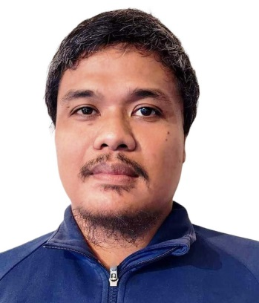
JACOB N. BLANCO
Zone 1, Brgy. Tambo, Buhi Camarines Sur
Mobile No.: 0948-429-1621 / 0956-103-6998
Email add.: blancojacob87@gmail.com

OBJECTIVE
A career with a progressive organization that will use my education, skills, knowledge, abilities and experience where I can effectively contribute to operation in any capacity that will help the company gain success and progress.

WORK EXPERIENCE:

SENIOR ELECTRICIAL TECHNICIAN
Tagat Al-Sharq AlSaudi Factory
Makkah Road, Dammam, king of Saudi Arabia
(Oil and Gas Refinenary)
April 2011-May 2015
(4 years in Service)

Description:
-installation of electrical power and motor control
-perform troubleshooting and repair mechanical and electrical problem
-maintains inventories of equipment parts and supplies by checking stock and placing orders.
-perform emergency repair for electrical problem
-run diagnostic tests to ensure system functionality.
-provides electrical maintenance information by answering questions and request.
-provide preventive maintenance and monitoring of oil and gas machinery.

-install and inspect electrical power motor control, sensors and alignment and switch board and wirings.
-provide preventive maintenance of electrical machines.
-repair and maintain robotics sensor
(P.E., Proximity, Reed Switch)

INDUSTRIAL ELECTRICIAN
Vector Electrodynamic Technologies Inc.
Champaka cor. Santan St. Brgy. Parang Marikina City, Philippines
(Electrical power and component distributor & contractor
August 20070- April 2011

Description:
-performing preventive maintenance for pneumatics and hydraulic machineries
-PLC wiring
-Dismantles machinery / electrical cable and removes / replaces defective parts
-maintain a safe and clean work environment by complying with procedures, rules and regulations.
-run diagnostic test to ensure system functionality

OTHER SKILLS: Driving, Able to read Electrical Plan

EDUCATIONAL ATTAINMENT:

MARIKINA POLYTICNIC COLLEGE
Major in Industrial and Mechatronics Technology
Three-Year Diploma of Technology
2003-2006

TRAINING AND SEMINARS

Production Maintenance Skills
Organized by Overseas Vocational Training Association (OUTA)
and Ministry of Labour of Japan
July 25 – August 5, 2005

Electrical and Instrumentation Panel Field wiring
December 01, 2007 – February 03, 2008

CERTIFICAT OF EXCELLENCE
For outstanding performance and lasting contribution on full company operations of the factory and successful
Plant Shut-down
Dammam, King of Saudi Arabia
December 2012

Completed the 288-hour of production site
Coats Manila Bay
May 2005

PERSONAL DATA:

Birthdate : November 05, 1986
Gender : Male
Age : 36
Marital Status : Married
Nationality : Filipino
Religion : Roman Catholic
Language : Filipino, English, Basic Arabic

