Educational Attainment:  - Tertiary Education  University of the Cordilleras  Baguio City, Philippines  S.Y 2009 - 2013  - Secondary Education  - Pines City National Highschool (Bonifacio Annex)  Baguio City, Philippines  S.Y 2005 - 2009  - Elementary Education  Santiago South Central School  Santiago , Ilocos Sur, Philippines  S,Y 1999 – 2005  Personal Details:  Gender: Female  Birthdate: July 11, 1993  Civil Status: Single  Height:5'3"  Citizenship: Filipino  An enthusiastic team player, business minded with a goal oriented personality.  Build trust, value others, communicate effectively, drive execution, faster innovation, collaborate with others, solve problems creatively and demonstrate high integrity.  Have a proven ability to work effectively in a team with people from different cultures.  Good interpersonal skills and ability to deal with people effectively.  A quick learner & an energetic self-starter with excellent analytical and creative skills.  Strong time management abilities and organizational skills.
  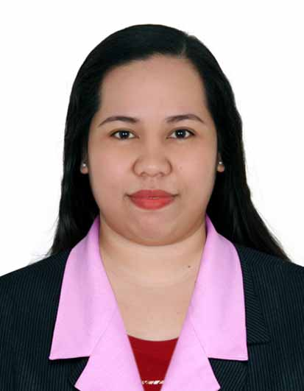
  Contact Information
  Address: Bulbulala, Santiago, Ilocos Sur, Philippines
  Contact #: +639451879929
  Email:Maridelbacha2019@gmail.com
  Professional Strength
  Skills
  Computer Literate:
  (MS Word, Excel & Power point)
  Data entry
  Document management & Filing
  Basic Accounting
  MARIDEL E. AVELLANO
  Career Objective
  To be a part of company that indulges professional growth which provides challenging and rewarding career while allowing me to utilize my knowledge and skills.
  Summary of Qualifications
        - Two years working experience in a business center as coordinator.
  - More than 1 year working experience in UAE with in Bank field.
  - 2 years working experience in Philippines with the following field Real Estate & Customer Service.
  - Proven initiative and ability to work with minimal supervision.
  - Knowledge of the organization, reports, charts and leasing invoices
  - Good team player and multitasking capabilities
  - Fast-learner and dedicated in delivering team success
  - Strong knowledge of current computer environments; i.e., Microsoft Office software & the Internet and with a typing speed of 30-40 WPM.
  - Profound knowledge of software programs such as Microsoft Word, Excel and PowerPoint,
  - Direct reporting and provide assistant to the Sales Executive, Sales & Marketing Manager, Line Managers, Department Heads and Supervisors.
  - In-depth knowledge of the organization and maintenance of filing systems.
  - Strong ability to apply instructions and guidelines in the disposition of problems.
  - Ability to follow complex instructions.
  - Ability to interact to business clients.
  - Interacting with customers, providing information in answer to inquiries.
  Employment Record
  Business Center Coordinator
  August 03, 2016 to December 15, 2019
  Dubai International Financial Center
  Dubai, UAE
  Duties and Responsibilities:
  - Handling reception
  - Ensure to be present at all times at the workplace
  - Maintain a positive and friendly environment at all times
  - Welcomes clients & visitors by greeting them
  - Attends clients complaints and queries
  - Prepares monthly pantry requisition for all business center location
  - Handling 46 offices
  - Coordinate with clients with regards to their lease renewals
  - Update files in the system
  - Prepare & book meeting rooms
  - Printing, Scanning & Filling of files
  - Writes & prepares letters, memos, emails & reports
  - Coordinating with existing tenants regarding rental payments
  - Ensuring adequate stock for stationery items for all business center location
  - Make follow ups on the delivery of the pantry & stationery requisition
  - Assist clients with basic administrative task (typing, photocopying, faxing & other clerical task)
  - Coordinate with Zone Parking for the unreserved parking space of new tenants.
  - Prepares refund for move out clients
  - Prepare EXIT NOC
  Data Entry Operator
  September 10, 2014 to April 28, 2016
  First Abu Dhabi Bank (FAB)
  Dubai, UAE
  Duties and Responsibilities:
  - Doing the data entry for credit cards and loans
  - Coordinate through phone calls and internal mails.
  - Perform clerical duties of scanning, maintaining and retrieving of all records and work files.
  - Scrutiny and verify information regarding customers/company as narrated in their application form.
  - Coordinates with Administrative Staff
  - Enter data from source documents into prescribed computer database
  - Coordinate with sales supports
  - Check source documents for accuracy
  - Comply with data integrity and security policies
  - Keep data and files confidential
  - Updates any required customer or company level of information changes such as address changes, contact information updates to maintain accurate account.
  - Ensures security of all personal identifiable information to prevent theft of client information.
  - Scan, maintain and manage files
  - Scan documents into document management system or databases
  - Maintain records of daily works for future references
  - Prepare daily batches of productivity
  - Send daily batch of productivity to records management team
  - Prepare and send emails for the batch send for daily productivity
  Document Controller cum Secretary
  June 2012 to March 2013
  Goshen Land Capital Inc.
  Baguio City, Philippines
  Duties and Responsibilities:
  - Assisted visitors and clients
  - Prepare monthly schedules of the employees
  - Do surveys outside the working place
  - Manage records of the employees
  - Maintain records of the clients
  - Prepare business plans
  - Conduct seminars for student interns
  - Manage cash and sales transactions in dining facilities. Their responsibilities include promoting services, improving customer satisfaction, answering to inquiries, reporting to the restaurant's manager, and greeting customers.
  Customer Service Representative cum Cashier
  March 2011 to September 2011
  McDonalds Philippines
  SM Baguio, Philippines
  Duties and Responsibilities:
  - Greet customers coming in and out of the food chain
  - Taking orders of the customers
  - Keep records amount received
  - Prepare reports of transactions
  - Keep totals money received by the end of the day
  - Practice honesty and trustworthiness
  - Collects money through cash, checks and by debit/credit card
  CHARACTER REFERENCES: Available upon request.

