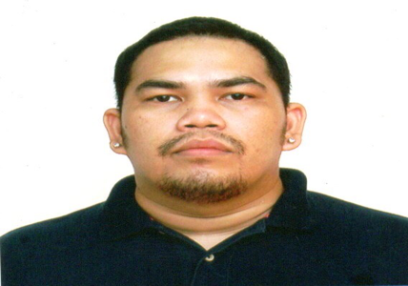

Ramie Benedicto
Blk. 8 lot 13, San Mateo Village, Brgy. Banago BC |
09459617740
rambenedicto823@gmail.com

Personal details

Ramie Macahito Benedicfo
41 years old
5’8
95 kg.

Skills Summary

I can work with minimum supervision, can multitask, and can work well with other people. I know my way through microsoft office.

Education

BS HRM |La Consolation College Bacolod
April 2001

Lifeline International Health Institute
2023 Feb. To 2023 Aug.

Experience

Magsaysay Corp

Bartender / Dec 2005-August

2009 November

Focus Inc

CSR / August 2016-August 2017

Teletech

CSR / January 2018 to present

Cova tapas y Sangria
Bartender/2013 Aug. to 2014 September

22 jupiter
Bar manager 2014 October to 2015 August

VOLUNTEER FIRST AIDER
BACOLOD DISASTER RISK REDUCTION MANAGEMENT OFFICE
Aug 2023 to Present

DIGITAL MARKETING SPECIALIST
(ADVERTISING AND MARKETING)
Freelance
Dec 2021 to Present

