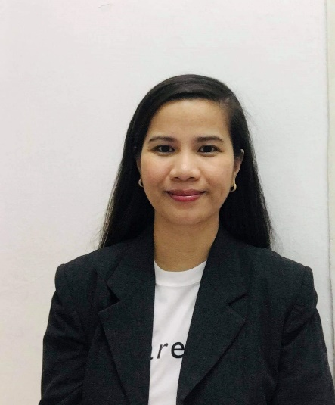
Name: ALGRACE DELA CRUZ MERONG
Mobile No.: +639193676487
Email address: algracem28@gmail.com

OBJECTIVES:
Interested in any job that commensurate to my abilities and qualifications and to work in a place that gives me opportunity to use, share and enhance my knowledge, skills and abilities. I am also interested in meeting new people and learning new experiences.
PERSONAL INFORMATION:
Date of Birth: September 28, 1983
Address: #21 Bliss Site Housing Pagal San Carlos City Pangasinan, Philippines
Civil Status: Single
Citizenship: Filipino
Height: 5’3”
Weight: 55 kgs
Religion: Born again Christian
Father’s Name: Pablo A. Merong (Deceased)
Mother’s Name: Loreta C. Merong (Deceased)

EDUCATION:
Tertiary Education (2001-2006)
Bachelor of Science in Nursing
Virgen Milagrosa University Foundation
Martin P. Posadas Ave., San Carlos City Pangasinan
Secondary Education (1997-2001)
Saint Charles Academy
Malong St., San Carlos City, Pangasinan
Primary Education 1991-1997
Ednas School of San Carlos (1991-1994)
Roxas Blvd., San Carlos City Pangasinan
Saint Charles Academy (1995-1997)
Malong St., San Carlos City, Pangasinan

EXPERIENCES:
1. Emergency and Medical-Pedia Ward Staff Nurse (July 2006-April 2007)
Elguira General Hospital
Rizal Avenue San Carlos City Pangasinan
Job Description:
- Maintain accurate, detailed reports and records.
- Monitor, record and report symptoms and changes in patient’s conditions.
- Record patient’s medical information and vital signs.
- Modify patient treatment plans as indicated by patient’s response and conditions.
- Consult and coordinate with health care team members to assess, plan, implement and evaluate patient care plans.
- Order, interpret, and evaluate diagnostic tests to identify and assess patient’s condition.
- Monitor all aspects of patient care, including diet and physical activity.
2. Caregiver
Rivka Kaskas, 57 years old (August 16, 2009 – November 6, 2009)
Fikus 1/7 Modi’in Israel
3. Elderly Caregiver
Sarina Cohen, 83 years old (November 18, 2009 – November 18, 2011)
Mivza Sinai #31 Bat Yam Israel
4. Elderly Caregiver
Varda Bogen, 89 years old (January 1 2012 – October 31, 2013)
David Hamelech #51 Tel Aviv Israel
5. Elderly Caregiver
Pnina Gelb, 93 years old (November 11, 2013 – December 15, 2022)
Harazim 2 Beit Abot 2 Ramat Efal Ramat Gan Israel
Job Descriptions:
- Assist with walking and light exercises.
- Plan and prepare meals, followed by clean-up.
- Monitor food expiration dates, make future meals.
- Make beds and change lines, as needed.
- Light Housekeeping to include dusting and vacuuming.
- Assist with bathing, dressing and grooming.
- Laundry and ironing.
- Take out garbage.
- Run errands (pick up prescriptions, buy medicines and groceries).
- Provide medication reminders.
- Escort on appointments (hair salon, physical therapy and etc.)
- Escort to religious services and events.
- Maintain calendar and organize mail.
- Engage in activities (games, memory books)
- Companionship.
- Change diapers.

EXAMINATION TAKEN:
- Licensure Examination for Nurses: Passed
SEMINARS ATTENDED AND CERTIFICATIONS:
- Basic Leadership Training
Philippines Red Cross Pangasinan Chapter
Virgen Milagrosa University Foundation
San Carlos City Pangasinan
August 3-4, 2002
- Nursing Care Management on Elderly Patients with Psychiatric Disorder
VMUF College of Nursing
Virgen Milagrosa University Foundation
San Carlos City Pangasinan
September 28, 2005
- Resolving Conflicts in the Healthcare Setting
Excel Care Training and Seminar
Dagupan People’s Astrodome
Dagupan Pangasinan
September 16, 2006
- Helping Patients Cope with Loss, Grief and Mourning
Excel Care Training and Seminar
Dagupan People’s Astrodome
Dagupan Pangasinan
September 16, 2006
- Intravenous Therapy and Regular IV Training Program
Pangasinan Provincial Hospital
Bolingit San Carlos City Pangasinan
June 6,7 & 8, 2007
- Philippine Nurses Association
Pangasinan Chapter
Gapuz Centrum, Bolosan District, Dagupan City
July 20, 2007
- National Certificate II in Caregiving
Technical Education and Skills Development Authority
Manila Philippines
April 3, 2009
- Basic Life Support and Advanced Cardiac Life Support
American Heart Association Accredited
Region 1 Hospital Dagupan City
July 1, 2023

CHARACTER REFERENCES:
1. Mrs. Gloria Canilang – Barangay Captain
Cacaritan San Carlos City Pangasinan
2. Ms. Carla Elguira, RN, MAN – Chief Nurse
Elguira General Hospital
Rizal Ave., San Carlos City Pangasinan
3. Ma. Theresa Aguilan, RN, MAN – Dean College of Nursing
Virgen Milagrosa University Foundation
Martin P. Posadas Ave., San Carlos City Pangasinan
4. Eitanimor – Placement Agency
Hayarkon #74 Tel Aviv, Israel

