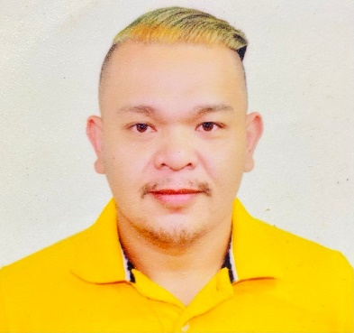
Lino G. Cordovez
857 9 de Pebrero st., Mandaluyong City./Bgy. Oples, Liliw, Laguna
02-5316114 /09959723042
lynus_17@icloud.com

OBJECTIVES
To incorporate my knowledge, talent and skill to fulfill the Vision of the company and to be a key individual to be a part of the success of the group.
EDUCATION:
2002-2004 A.B.POLITICAL SCIENCE RIZAL TECHNOLOGICAL UNIVERSITY
(POST GRADUATE) (BONI AVE. MANDALUYONG CITY)
2005-2009 B.S NURSING OUR LADY OF GUADALUPE COLLEGES
(GRADUATE) (SEIRRA MADRE COR ESTEBAN ST. MANDALUYONG CITY)

ACTIVITIES:

- MEMBER, RED CROSS OF THE PHILIPPINES 2006-2012
- SINGLE FOR CHRIST
- MEMBER, GENESIS CHOIR (OUR LADY OF FATIMA PARISH)

EXPERIENCE:

LOANS ORIGINATION ASST.
PROPERTY COMPANY OF FRIENDS INC
2010-2011

RESPONSIBILITIES

- Assess the client monitoring to determine the reservation date
- Print welcome letter, notice.
- Send mail and ensure the mail are well documented

LOANS ORIGINATION TEAM LEADER
PROPERTY COMPANY OF FRIENDS INC
2012-2014

RESPONSIBILITIES

- Analyzed loan applications of diverse applicants
- Suggest loan products, including different financing.
- Collected all essential information and documents from clients completing loan applications.
- Conducted background checks and verifications to ensure the customer fulfills all conditions.
- Oversee the problem of my handled co-worker.
- Generate daily report.
LOANS ORIGINATION SERVICING ASST.
PROPERTY COMPANY OF FRIENDS INC
2014-2015

RESPONSIBILITIES

- Assisted customers by assuaging their doubts and clarified different credit policies.
- Coordinated with department and underwriters in solving loan related issues.
- Guided clients on additional issues
- Worked in coordination with credit analysts to clarify customer‘s credit record.
- Generate daily report.

DOCUMENTATION AUDIT AND CONTROL ASSOCIATE
ROPERTY COMPANY OF FRIENDS INC
2015-MARCH 2017

RESPONSIBILITIES

- Evaluate physical and electronic document
- Tagging evalutated documents of the client to monitoring.
- Print forms, contracts of client. And evaluate them.
- Delivered the clients documents and file to HDMF office.
- Generate daily monitoring
- Report to manager.

SITE ACQUISITION OFFICER
JEZKA COMPANY
JULY2017 – SEPT. 2017

- Conduct surveys on land sites and properties
- Examine previous records and evidence to ensure data accuracy
- Research and design methods for survey processes
- Use equipment and tools to accurately measure land features (e.g. longitudes, latitudes)
- Build maps, sketches, and charts
- Supervise and provide guidance to field staff
- Purchase and maintain equipment
- Report on survey results and present findings to clients
- Collaborate with engineers and architects on several projects

PRIVATE NURSE
RIYADH (KHALID ABDULMOSEEN)
AUG 2018 – APR 2023

RESPONSIBILITIES

- Collect patient/s information thru systematic procedure
- Coordinated / Referred to Doktor the information collected
- Assisted Patient/s to their everyday activities
- Carry out Doktor/s order
- Ensure the comfort and safety if the patient
- Guided patient to use their capabilities to overcome illness
- Ensure patient positive look in Life

AWARD:
- FMGREAT REWARD FOR EMBODIED THE CORE VALUES “INNOVATION”
- PROPERTY COMPANY OF FRIENDS GROUP AWARD “INNOVATION”

CHARATER REFERENCES

KEILEEN CABELLO MANAGER (DACG) PROFRIENDS INC. 09156472454
PEARL BALLESTEROS OFFICER PROFRIENDS INC. 09275853494
MOHAMMAD DUWIDAR AMIL IDRIS NURSE ABDULMOSEEN KHALID 09568742352

