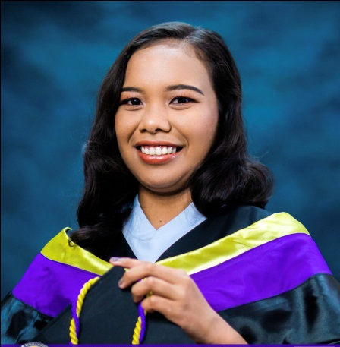
FAYE ANGELA P. BARUT
Jordan, Sinait, Ilocos Sur
Mobile No. 09350916776
Email: liamalexziander@gmail.com

PERSONAL INFORMATION
Birthdate : November 29, 1997
Age : 25
Gender : Female
Citizenship : Filipino
Religion : Roman Catholic
Civil Status : Single
Father’s Name : Gilbert A. Barut
Occupation : Farmer
Mother’s Name : Joselyn P. Barut
Occupation : Housewife
In case of emergency please contact : Joselyn P. Barut
Contact Number : 09153024146
QUALIFICATIONS
- Honest
- Hardworking and dedicated to work
- Adapts to work schedule
- Skilled on verbal and written communication
- Goal oriented and competent
- Computer literate

*EDUCATIONAL BACKGROUND
TERTIARY : Bachelor In Medical Laboratory Sciences
University of Northern Philippines
Tamag, Vigan City, Ilocos Sur
2014 – 2019
SECONDARY : Sinait National High School
Ricudo, Sinait, Ilocos Sur
2010 – 2014
Elementary : Sinait West Central School
Macabiag, Sinait, Ilocos Sur
2004 – 2010
CLINICAL TRAINING :Mariano Marcos Memorial Hospital and Medical Center
Batac, Ilocos Norte
January 2019 – July 2019

INTERN
Has satisfactory completed the six-month training in:
- Clinical Chemistry
- Hematology
- Immunology and Serology
- Blood Banking
- Clinical Microscopy
- Parasitology
- Microbiology
- Histopathologic Techniques And Cytology

*WORK EXPERIENCE
FOOD HANDLER : Thick and Thin
Sinait, Ilocos Sur
LABORATORY ASSISTANT : Sto. Cristo Milagroso Hospital
Sinait, Ilocos Sur

I hereby certify that the above information are true and correct to the best of my knowledge and belief.

FAYE ANGELA P. BARUT

