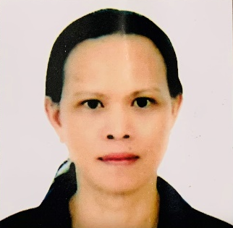
ESTEBAN O. VILLARIN
Bacag Centro, Villasis, Pangasinan
Mobile No: +63454171609/+639917372012
Email Address: estebanvillarin1077@gmail.com

ABOUT ME
- Dedicated and Enthusiastic professional with over five years experiences in working in a team.
- Consistently received outstanding feedback from superiors and team members.
- Proven expertise in establishing report and building trust with team members
From a variety of background.
I. WORK EXPERIENCE
Factory Worker: Jeongwon Sanoup / South Korea / September 2016 to August 2018
Private Duty: *(Elderly Patient) Philippines -157 hrs.
*(Child Patient) Philippines – 158 hrs.
* 1 Year Duty Elderly Patient
II. Education
CAREGIVING NCII
FIL-CANADIAN DEVELOPMENT TRAINING CENTER
Urdaneta City, Pangasinan Philippines

HIGH SCHOOL DIPLOMA
Don Ramon E. Costales Memorial National High School
Villasis, Pangasinan Philippines
1996

ELEMENTARY
Bacag Central School
Villasis, Pangasinan Philippines
III. Skills
First Aid or Emergency Responder

IV. Language Spoken
English, Filipino, Ilocano, Korean
V. Character References
Raul O. Padilla Bong Mortera
Punong Barangay Barangay Kagawad
Brgy. Bacag, Villasis Pangasinan Brgy. Bacag, Villasis Pangasinan
+6375 564 7802 +6375 564 7802

I hereby certify that the above information is true and correct to the best of my knowledge and belief.

ESTEBAN O. VILLARIN
Applicant

